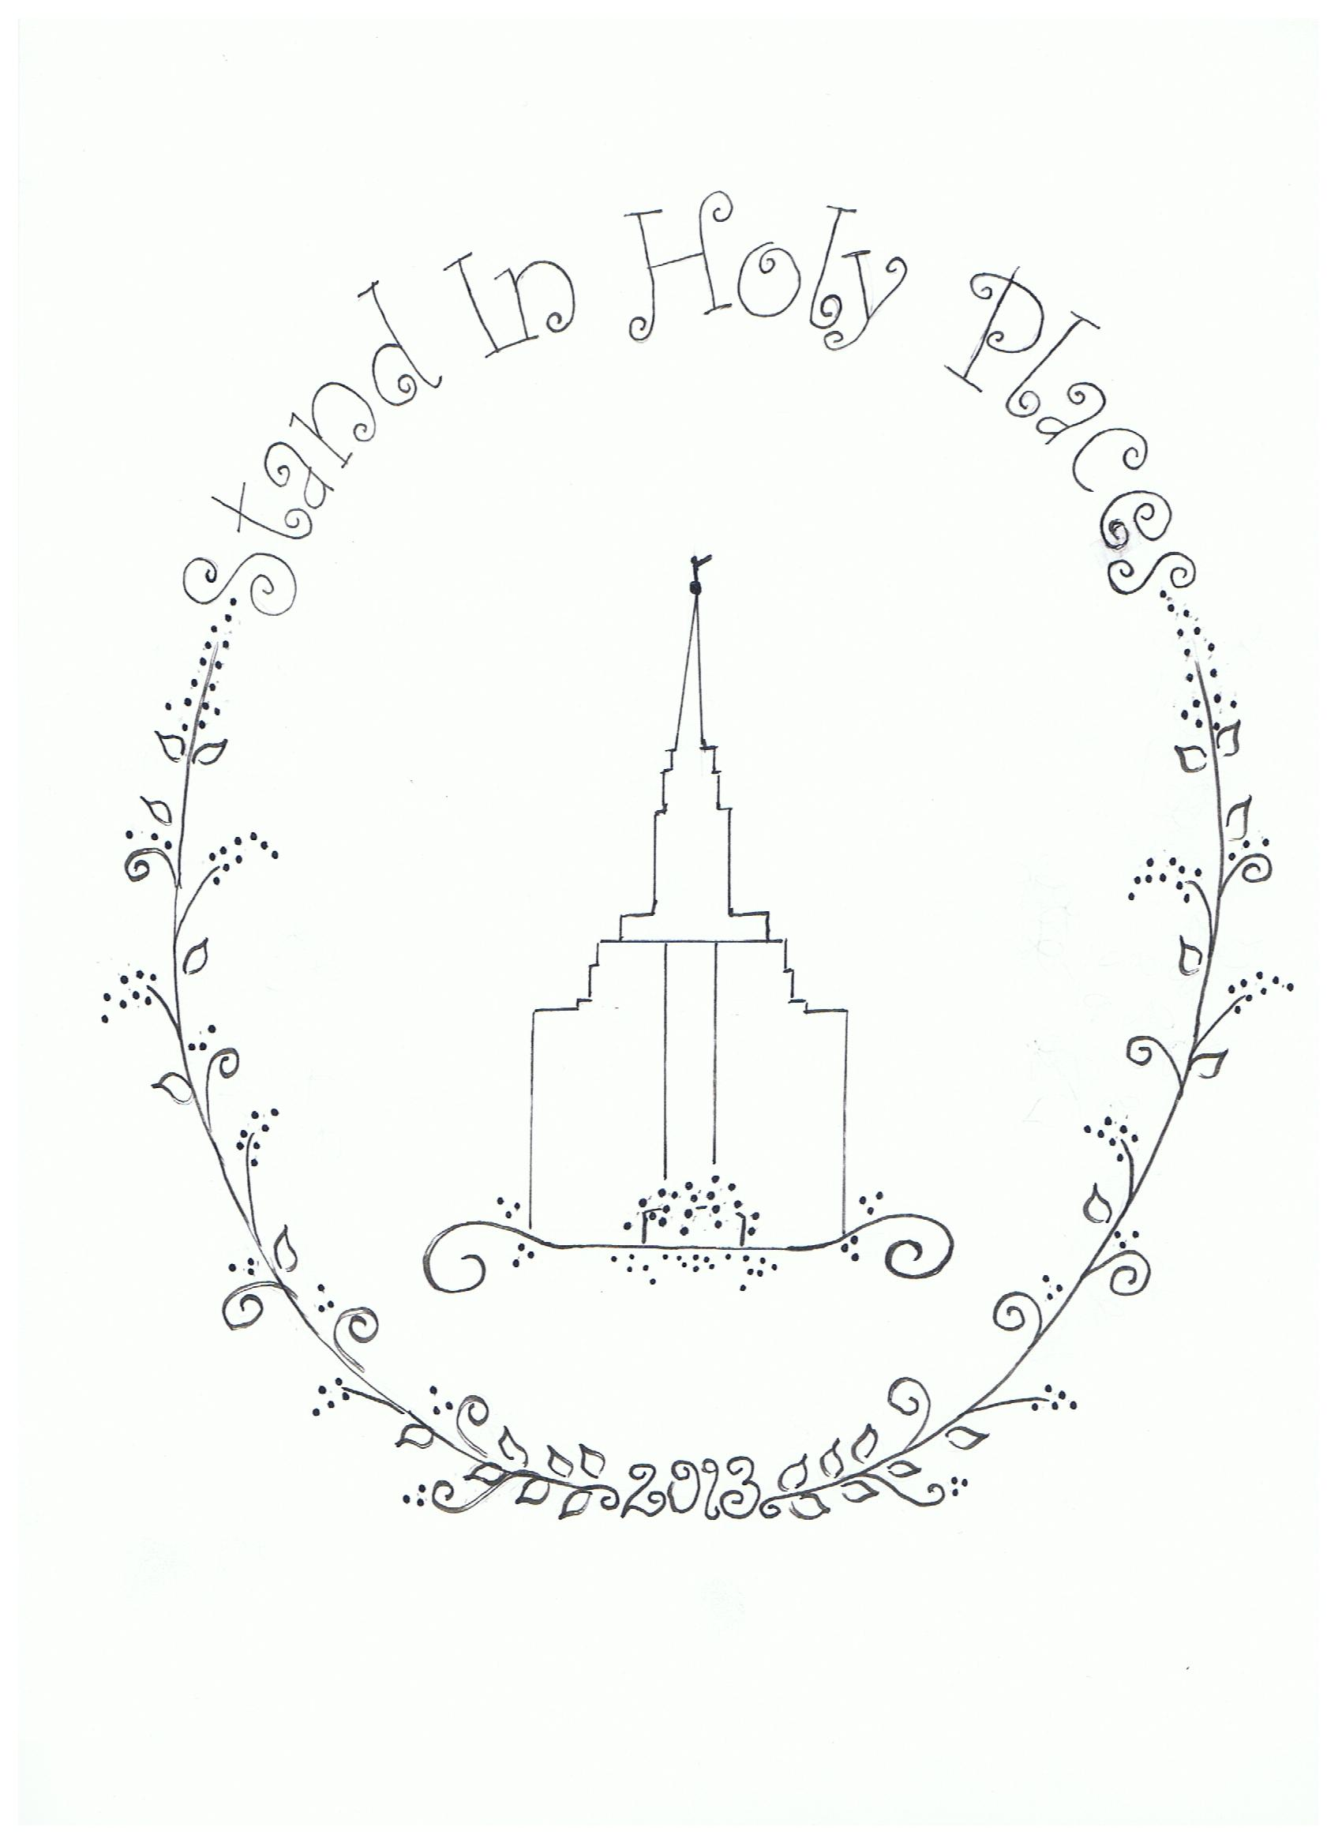
"Stand In Holy Places”
8” x 8” square sampler

by
Erlyn Barlocker
©Erlyn Barlocker 2012 – Herriman, Utah USA

Stitching Instructions:

- Copy the pattern onto 9”x9” or larger muslin or other light material.
- (Optional: add warm-n-natural cotton batting to back of muslin before stitching for a quilted look. If using white material, make sure you use white warm-n-natural).
- Stitch center vine and curls with #3052 green.
- Stitch vine under temple with #3052 green.
- Stitch all leaves with #3348 light green.
- Stitch lines of temple with #413 dark grey .
- Stitch all the words with of #413 dark grey.
- Stitch year on bottom with either #413 dark grey or 2 strands Gold metallic thread
- Stitch Angel on top of temple with either 2 strands Gold metallic thread OR #3045 gold floss.
- Stitch French knot at the base of the Angel using 2 strands Gold metallic thread OR #3045 gold floss.
- Stitch #327 purple French knots for flower buds on vine
- Stitch #3041 light purple French knots at vine curls on base of temple.
- Add mixture of #327 purple and #3041 lighter purple French knots for flower buds at base of temple.

Use backstitch and 2-ply floss for all stitching and French knots.

Finish product either as a pillow, framed work or quilt square.

** To see inspiration for sampler, please visit: https://www.lds.org/youth?lang=eng

©Shaggy Mountain Quilts
Is Erlyn Barlocker
Herriman, Utah
801-573-6200
shaggymountainquilts@gmail.com
Supplies Needed
Embroidery needle
Scissors
9” x 9” or larger muslin or light material
Small embroidery hoop
DMC Floss:
3052 green
3348 light green
413 dark gray
3045 Gold OR gold metallic thread
*327 purple
*3041 light purple

Optional
Warm-n-natural batting to match material
*Can use another Young Woman Value Color for flowers. Get a light and a dark.

