2014 ~ (Enter Ward) Ward Primary
Primary Presidency

President~
1st Counselor~
2nd Counselor~
Secretary~
Pianist~
Music Leader ~
Faith in God~

Primary Workers

Nursery~
Sunbeams~
CTR 4 & 5~
CTR 6 & 7~
Valiant 8 & 9~
Valiant 10 & 11~

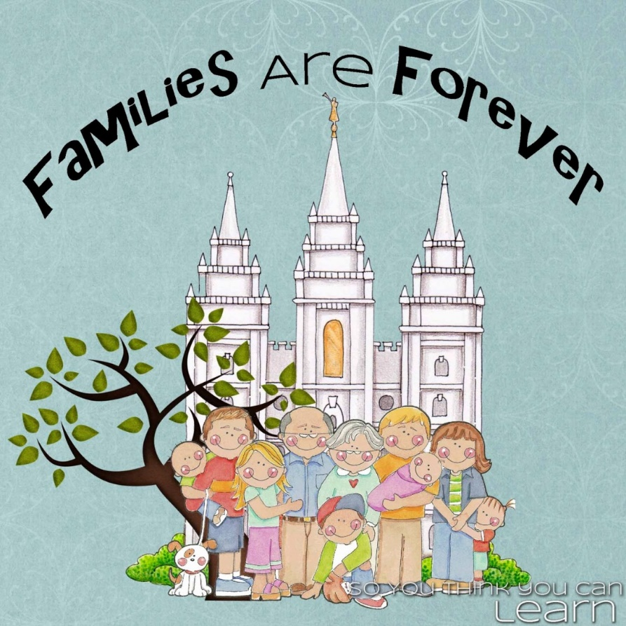

What is Primary?
The Primary is an auxiliary to the priesthood. All auxiliaries exist to help Church members grow in their testimonies of Heavenly Father, Jesus Christ, and the restored gospel. Through the work of the auxiliaries, members receive instruction, encouragement, and support as they strive to live according to gospel principles.

What is the theme of Primary?
The Primary theme is “All thy children shall be taught of the Lord; and great shall be the peace of thy children” (3 Nephi 22:13).

What is the purpose of Primary?
The purposes of Primary are to help children:
- Feel Heavenly Father’s love for them.
- Learn and understand the gospel of Jesus Christ.
- Feel and recognize the influence of the Holy Ghost.
- Prepare to make and keep sacred covenants.
Parents have the first responsibility for the spiritual and physical welfare of their children (see D&C 68:25–28). The bishopric, Primary leaders, and Primary teachers support but do not replace parents in this responsibility.
Teaching Children
“The world will teach our children if we do not, and children are capable of learning all the world will teach them at a very young age. What we want them to know five years from now needs to be part of our conversation with them today. Teach them in every circumstance; let every dilemma, every consequence, every trial that they may face provide an opportunity to teach them how to hold on to gospel truths.”

~Rosemary M. Wixom, “Stay on the Path,” October 2010 general conference

Reaching the ONE
“I encourage you to reach out to those you serve and to love them. … True happiness and lasting joy will come to you and to each one you serve as you take a hand and reach a heart.”
~Thomas S. Monson, “Sugar Beets and the Worth of a Soul,” Liahona, July 2009, 2–5
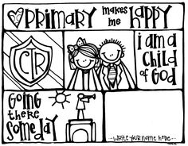
Love Those You Teach
Teachers and leaders show love and sincere concern for those they teach. They learn class members’ names. They review attendance information so they can be aware of class members who are not attending regularly. They may contact these members outside of class to encourage them in their participation.

Teach by the Spirit
Teachers and leaders seek the guidance of the Holy Ghost in preparing and teaching lessons. They seek this guidance by praying and humbly recognizing their dependence on the Lord. During lessons, they invite the Spirit by bearing testimony of the doctrines they teach.

Teach the Doctrine
Teachers and leaders use the scriptures, the teachings of latter-day prophets, and approved curriculum materials to teach and testify of the doctrines of the gospel. Approved curriculum materials for each class or quorum are listed in the current Instructions for Curriculum. As needed, teachers and leaders supplement curriculum materials with Church magazines, particularly the general conference issues of the Ensign and Liahona.

Invite Diligent Learning
Teachers and leaders encourage class members to be responsible for their own gospel learning as individuals, in their families, and during class instruction. They encourage class members to bring their own copies of the scriptures to class where possible. Teachers and leaders provide opportunities for class members to actively participate in discussions, and they invite class members to live the gospel and receive the promised blessings.
For More Information and Teacher helps go to: LDS.org
(There is so much training material and teacher help material to help you be a better teacher and help our sweet children in Primary)
