Old Testament, Lesson 14



Valiant Newsletter



Goal: I will desire to be honest and have integrity. I will be careful to tell the truth and be honest in all I do.

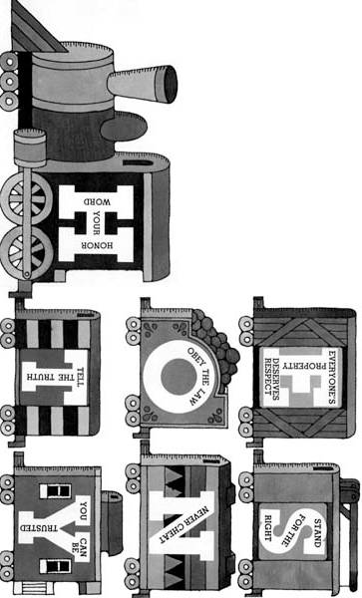
Old Testament Lesson 14
Jacob and his Family
- Read Genesis 29
- Fill Out the chart of Jacobs Family

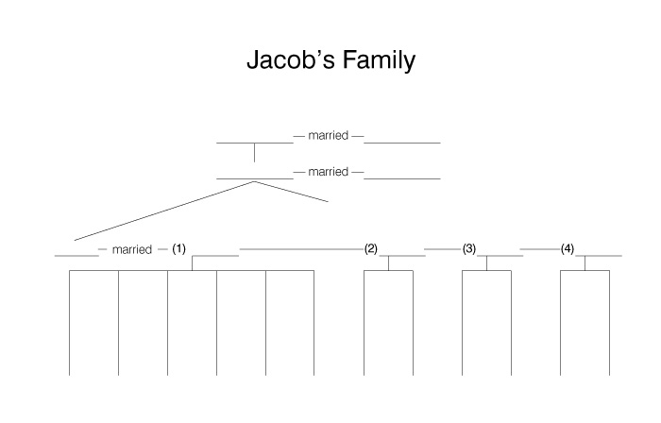

Challenge: Discuss the importance of being honest with your family.

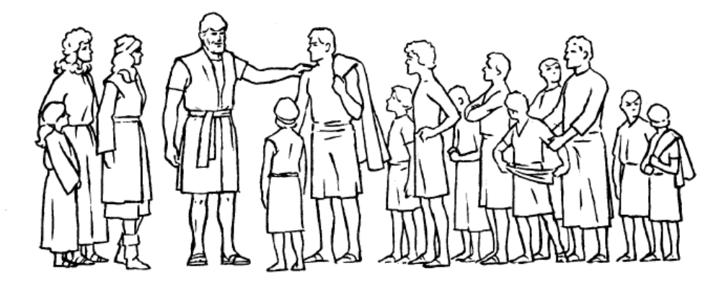

CRYPTOGRAM
A | B | C | D | E | F | G | H | I | J | K | L | M | N | O | P | Q | R | S | T | U | V | W | X | Y | Z
8 | 20 | 7 | 5 | 23 | 22 | 15 | 11 | 1 | 16 | 21 | 4 | 18 | 25 | 3 | 2 | 12 | 17 | 24 | 6 | 13 | 9 | 19 | 14 | 26 | 10

__ | __ |  | __ | __ |  | __ | __ |  | __ | __ | __ | __ |  | __ | __ |  | __ | __ | __ | __ | __ | , |  | __ | __ | __ | __
1 | 22 |  | 19 | 23 |  | 5 | 3 |  | 19 | 11 | 8 | 6 |  | 1 | 24 |  | 17 | 1 | 15 | 11 | 6 |  |  | 19 | 11 | 23 | 25

__ | __ | __ | __ | __ | __ | __ |  | __ | __ | __ | __ |  | __ | __ | __ | __ | __ | __ |  | __ | __ | , |  | __ | __ | __
24 | 3 | 18 | 23 | 3 | 25 | 23 |  | 23 | 4 | 24 | 23 |  | 19 | 17 | 3 | 25 | 15 | 24 |  | 13 | 24 |  |  | 6 | 11 | 23

__ | __ | __ | __ |  | __ | __ |  | __ | __ | __ | __ | __ |  | __ | __ |  | __ | __ | __ |  | __ | __ | __ | __ | __ | __ | __ | __ | __
4 | 3 | 17 | 5 |  | 1 | 24 |  | 8 | 19 | 8 | 17 | 23 |  | 3 | 22 |  | 3 | 13 | 17 |  | 24 | 1 | 6 | 13 | 8 | 6 | 1 | 3 | 25

__ | __ | __ |  | __ | __ | __ | __ |  | __ | __ | __ | __ | __ |  | __ | __ |  | __ | __ | __ |  | __ | __ | __
8 | 25 | 5 |  | 19 | 1 | 4 | 4 |  | 20 | 4 | 23 | 24 | 24 |  | 13 | 24 |  | 22 | 3 | 17 |  | 3 | 13 | 17

__ | __ | __ | __ | __ | __ | __ | __ |  | __ | __ | __ |  | __ | __ | __ | __ | __ | __ | __ | __ | __ | __ | __ | __ | __ | .
2 | 8 | 6 | 1 | 23 | 25 | 7 | 23 |  | 8 | 25 | 5 |  | 17 | 1 | 15 | 11 | 6 | 23 | 3 | 13 | 24 | 25 | 23 | 24 | 24

JACOB
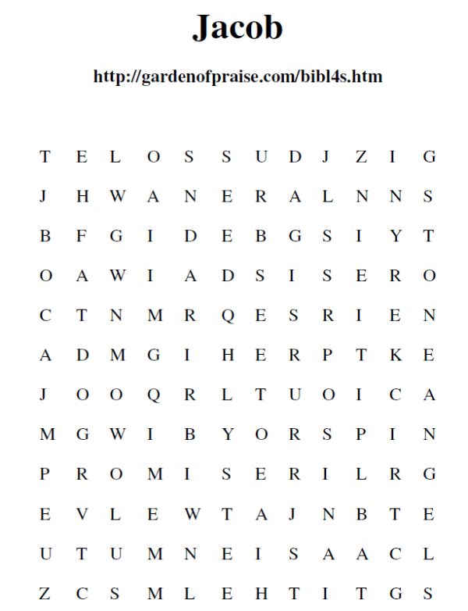
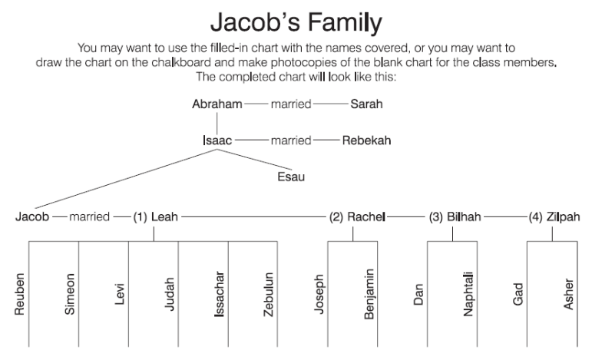
Honest Answer Key:: a.cheat; b.steal; c.tells the truth; d.bear false witness; e.returns borrowed items; f.gossip; g.cheat; h.keeps promises
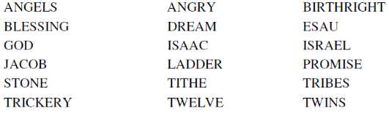
Unscramble Solution:
1. Judah
2. Gad
3. Reuben
4. Dinah
5. Asher
6. Issachar
7. Levi
8. Simeon
9. Joseph
10. Dan
11. Naphtali
12. Zebulun
13. Benjamin

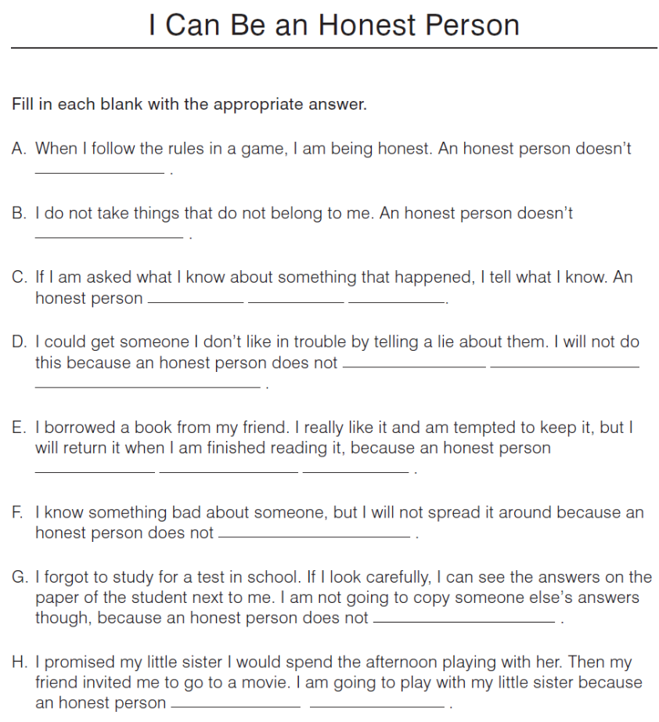
TRIBES OF ISRAEL
Find the twelve tribes of Israel as mentioned in Genesis 49:1-28, by reading forward, backward, up, down, and diagonally.

Asher Issachar Naphtali
Benjamin Joseph Reuben
Dan Judah Simeon
Gad Levi Zebulun

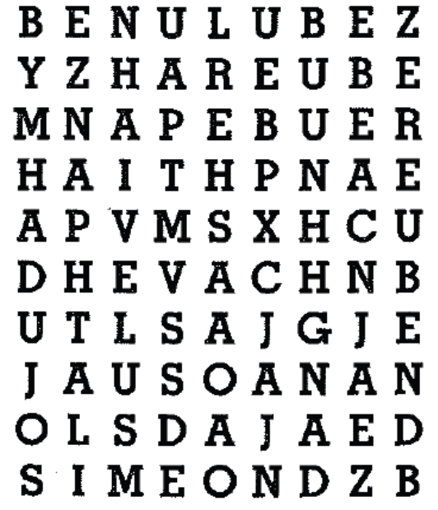

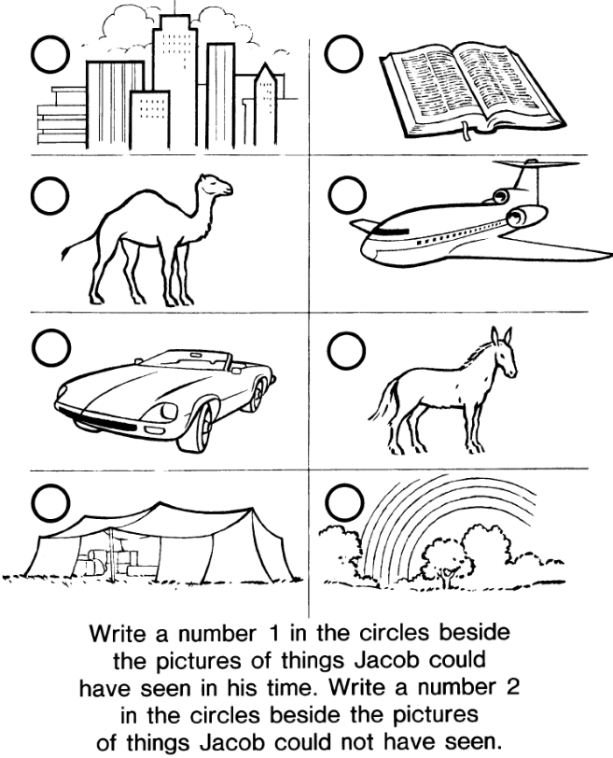
Unscramble the names of Jacob's Children
(Genesis 35:23-26)
1. | ___________________ | dajuh
2. | ___________________ | dga
3. | ___________________ | erneub
4. | ___________________ | nadih
5. | ___________________ | erash
6. | ___________________ | crisahas
7. | ___________________ | ilev
8. | ___________________ | onmesi
9. | ___________________ | poshej
10. | ___________________ | nda
11. | ___________________ | litanaph
12. | ___________________ | luebunz:
13. | ___________________ | jinenamb

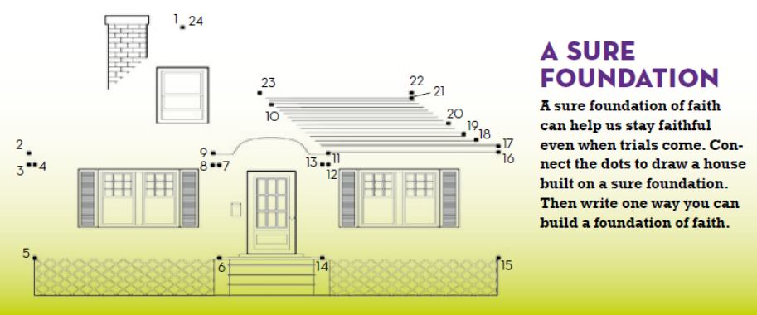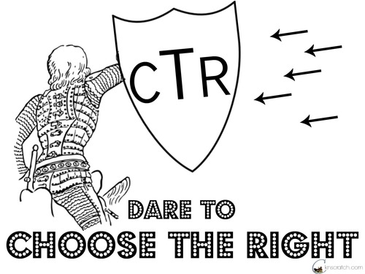

Elder Joseph B. Wirthlin
of the Quorum of the Twelve Apostles
shares some of his thoughts on:

What is integrity?
What can I do to have it?
To me, integrity means always doing
what is right and good, regardless
of the immediate consequences.
It means being righteous … , not only in our actions but, more importantly, in our thoughts and in our hearts.
We show our integrity by caring for and serving others.
The Lord expects us to live lives of integrity and to be obedient to his commandments.
Let us strive for personal, practical integrity in every endeavor, regardless of how mundane or inconsequential it may seem.
Having received the Spirit of Christ to know good from evil, we should always choose the good.

Stick to the Truth
Have a Heart—Keep Your Promises
Woolly Tales Lead People Astray
If Your Conscience Bugs You, Repent
“Leaf” Lies Alone
Lies Can Only Be Swallowed by Bigger Ones
Don’t Be Foolish—Tell the Truth
Shine for Light and Truth
A Clear Conscience Let’s You Fly Free
Stop and Think—Is It Honest?
No Time Is a Good Time for Gossip
Crime Doesn’t Pay
Friends Protect Friends from Showers of Lies
You’d Better Hop to It If You Promised to Do It
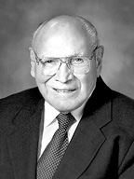

Draw a picture using one of the above statements to show how you can “Stick to the Truth”.



