Old Testament, Lesson 21



Valiant Newsletter



Goal: I understand that keeping the Ten Commandments helps me to be happy. The Lord gave us commandments because he loves us. Obeying these laws brings me happiness.

Challenge: Choose one specific way to show love for God and to show love for your neighbors this week.
Old Testament Lesson 21
The Ten Commandments
- Read Exodus 20:1-22
- Memorize One Commandment

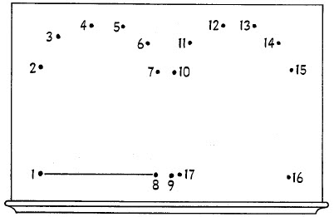

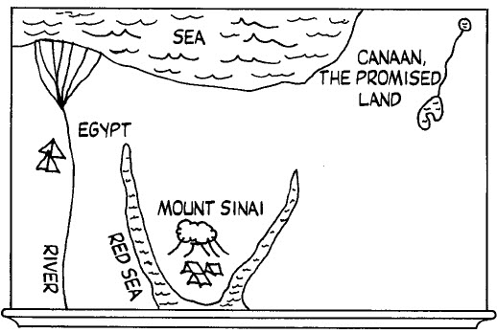

Help Me, Dear Father
1. Help me, dear Father, to freely forgive
All who may seem unkind to me.
2. Help me, dear Father, to truly repent,
Making things right, and changing my ways.
Help me each day, Father, I pray;
Help me live nearer, nearer to thee.

KEEP THE COMMANDMENTS
1. Keep the commandments; keep the commandments!
In this there is safety; in this there is peace.
He will send blessings;
He will send blessings.
Words of a prophet:
Keep the commandments.
In this there is safety and peace.
2. We are His children; we are His children,
and we must be tested to show we are true.
Hold to His promises;
Hold to His promises,
Heeding the prophets:
Keep the commandments.
In this there is safety and peace.

The Ten Commandments

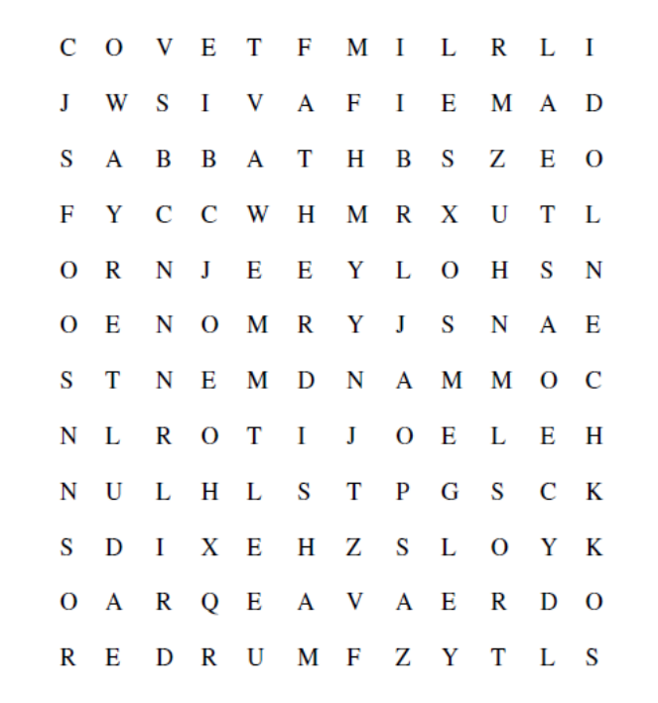

Help Me, Dear Father
1. Help me, dear Father, to freely forgive
All who may seem unkind to me.
2. Help me, dear Father, to truly repent,
Making things right, and changing my ways.
Help me each day, Father, I pray;
Help me live nearer, nearer to thee.

Help Me, Dear Father
1. Help me, dear Father, to freely forgive
All who may seem unkind to me.
2. Help me, dear Father, to truly repent,
Making things right, and changing my ways.
Help me each day, Father, I pray;
Help me live nearer, nearer to thee.




