Old Testament, Lesson 22



Valiant Newsletter

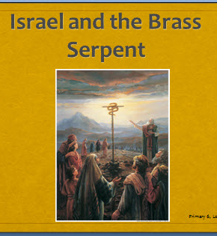

Goal: I can be humble and have faith in Jesus Christ. Heavenly Father has given me everything and I can be grateful for these blessings. Looking to Christ will help me find happiness and eternal life.

Old Testament Lesson 22
Israel and the Brass Serpent
- Read Numbers 21:4-9, John 3:14-15, D&C 112:10
- Can you join all the dots with one line and not use a dot twice?

Challenge:
Memorize the Thirteenth Article of Faith.



Help Me, Dear Father
1. Help me, dear Father, to freely forgive
All who may seem unkind to me.
2. Help me, dear Father, to truly repent,
Making things right, and changing my ways.
Help me each day, Father, I pray;
Help me live nearer, nearer to thee.

In Humility
1. In humility, our Savior,
Grant thy Spirit here, we pray,
As we bless the bread and water
In thy name this holy day.
Let me not forget, O Savior,
Thou didst bleed and die for me
When thy heart was stilled and broken
On the cross at Calvary.
2. Fill our hearts with sweet forgiving;
Teach us tolerance and love.
Let our prayers find access to thee
In thy holy courts above.
Then, when we have proven worthy
Of thy sacrifice divine,
Lord, let us regain thy presence;
Let thy glory round us shine.

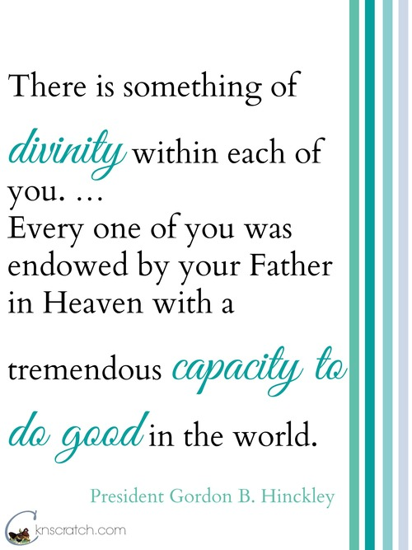

Help Me, Dear Father
1. Help me, dear Father, to freely forgive
All who may seem unkind to me.
2. Help me, dear Father, to truly repent,
Making things right, and changing my ways.
Help me each day, Father, I pray;
Help me live nearer, nearer to thee.

Help Me, Dear Father
1. Help me, dear Father, to freely forgive
All who may seem unkind to me.
2. Help me, dear Father, to truly repent,
Making things right, and changing my ways.
Help me each day, Father, I pray;
Help me live nearer, nearer to thee.


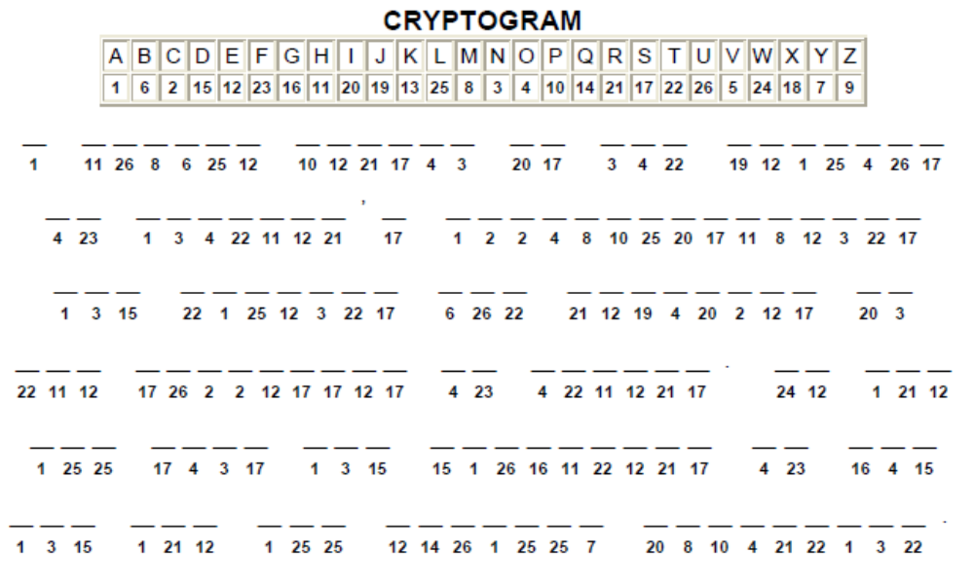

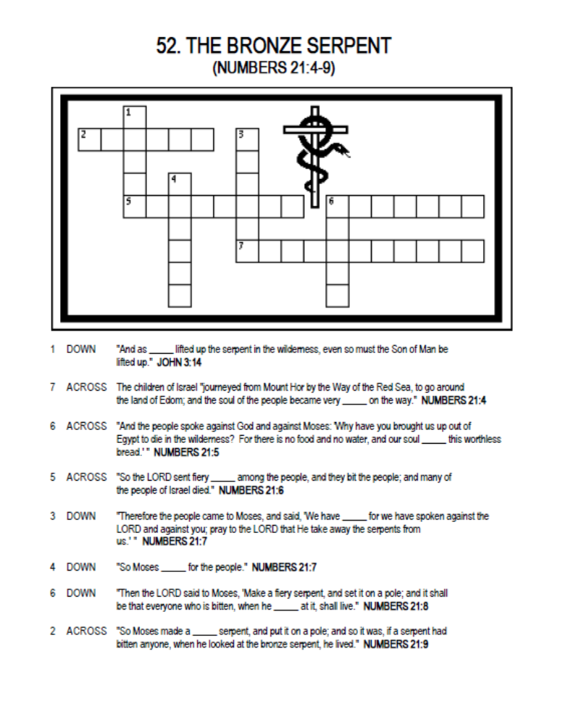
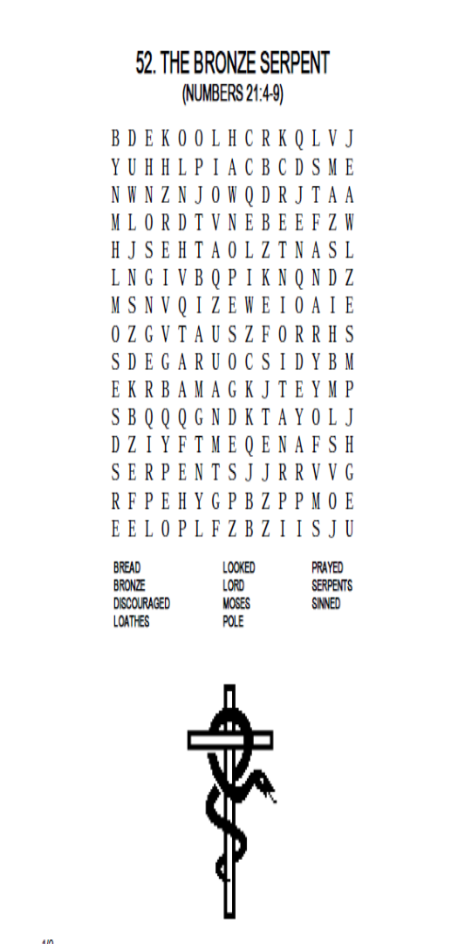

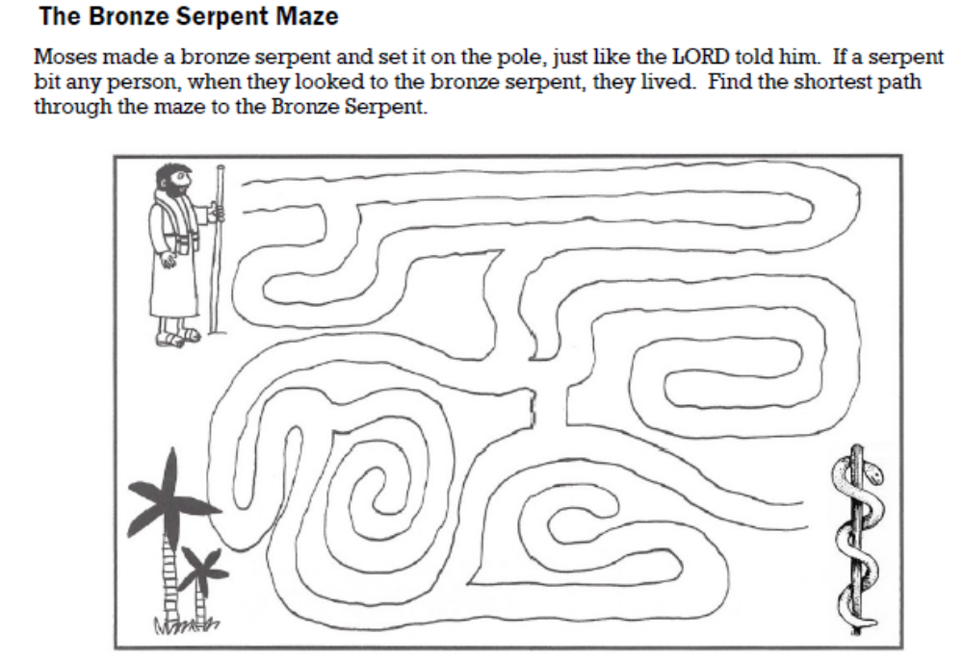

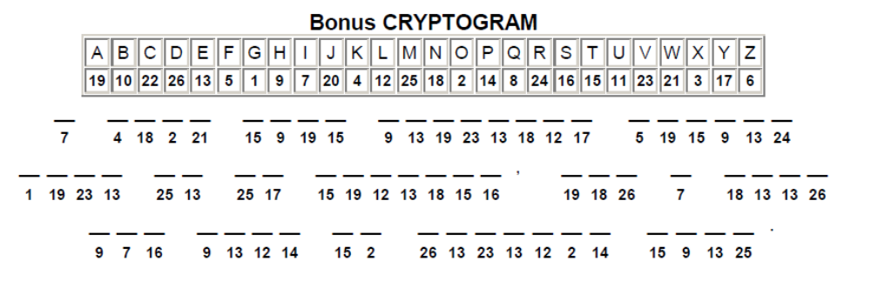

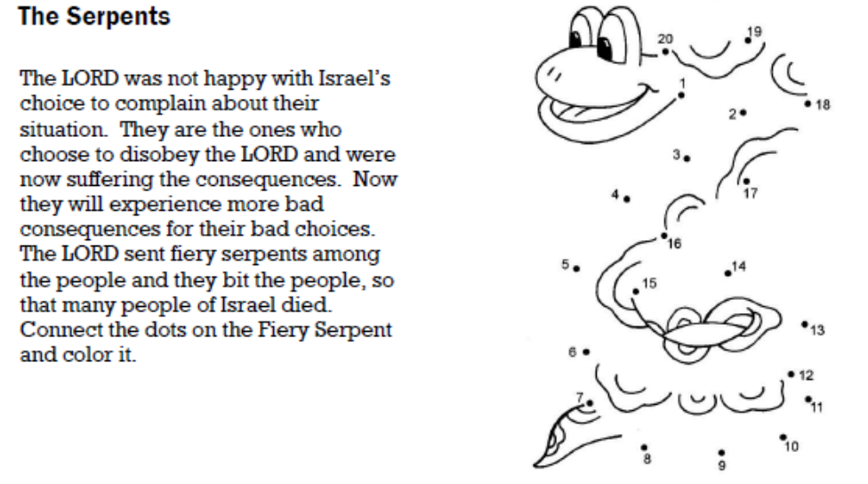
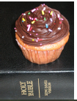
Some commandments are as simple to follow as looking at the Brass Serpent. Studying the Scriptures is one of these commandments. They are a great blessing given to us! They provide help, guidance, comfort and much joy. But we must look at them!
- The Cupcake symbolizes the Scriptures
- Everyday it sits there, some days we think how wonderful it tastes, some days we taste the frosting, but do we eat the entire delicious cupcake every day?
- It’s sitting there why don’t we eat it? It’s so easy, we know it will help us, make us happy, and make us better, so why don’t we eat it?

We know that some of the Israelites did not look at the brass serpent even though it was so easy to do. IS THAT LIKE US READING OUR SCRIPTURES? We know it will bless us, yet we don’t pick them up and read them consistently.
- Place a cupcake on top of your scriptures (hopefully close to your bed and easy to see).
- Be determined to eat your scripture cupcake everyday!




