Old Testament, Lesson 29



Valiant Newsletter

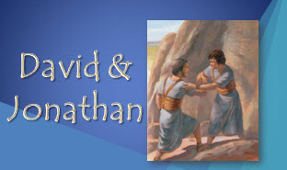

Goal: I will understand how to be a true friend. If I develop qualities of a true friend, I will be blesses with friendships that can be eternal I can strengthen my friendship with Christ by keeping his commandments and remembering him always.

Old Testament Lesson 29
David and Jonathon
- Read 1 Samuel 18: 1-4; 1 Samuel 20:1-42
- Fill in the Blanks. Words can be used more than once.
(1 Samuel 20:12-42)
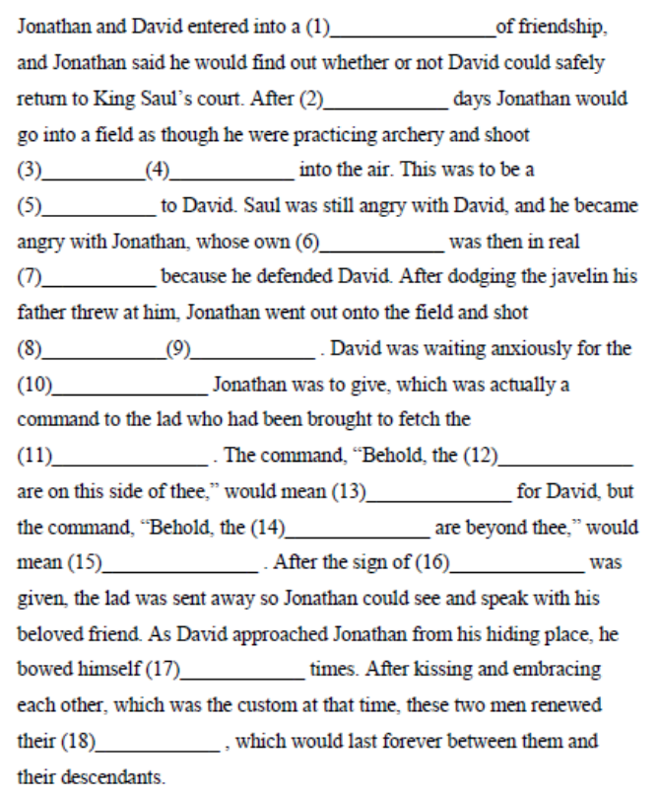
Challenge: Think of something I can do to show love and help someone I know. Then do it!.

We Are Different
1. I know you, and you know me.
We are as diff'rent as the sun and the sea.
I know you, and you know me,
And that's the way it is supposed to be.
2. I help you, and you help me.
We learn from problems, and we're starting to see.
I help you, and you help me,
And that's the way it is supposed to be.
3. I love you, and you love me.
We reach together for the best we can be.
I love you, and you love me,
And that's the way it is supposed to be.

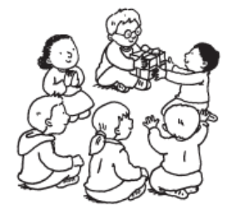

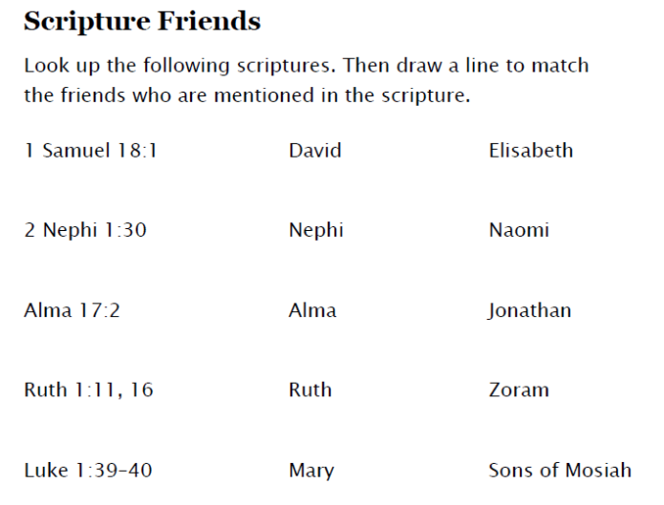

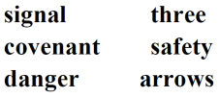

What is a covenant?
A solemn promise between two or more people.

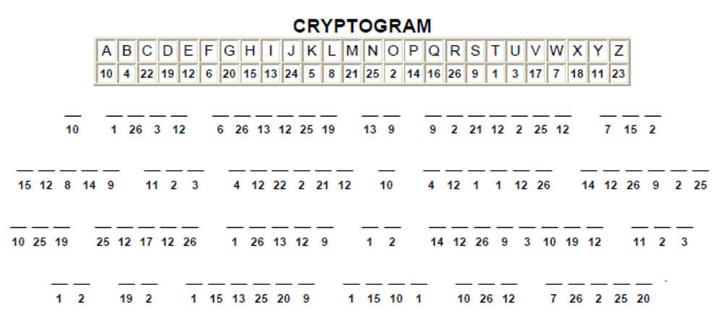
Fill-in Key: signal—5, 10; covenant—1, 18;safety—6, 13;
danger—7, 15, 16; arrows—4, 9, 11, 12, 14; three—2, 3, 8, 17

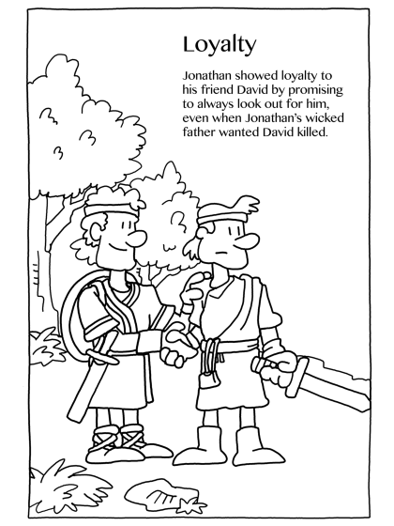
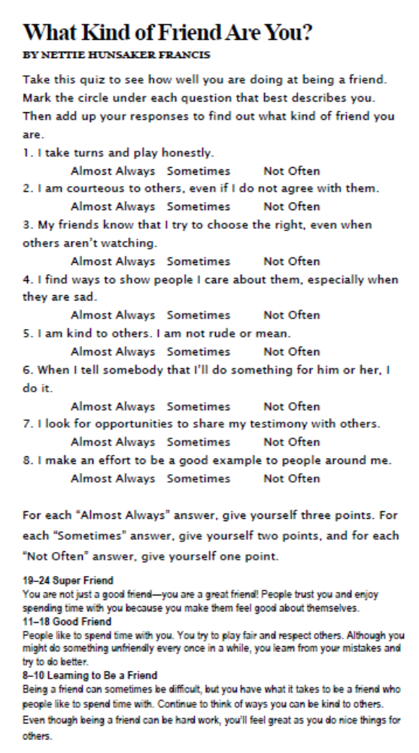
When we have friends in our lives, we need to treat them the way we would like to be treated; with respect, love, kindness and also to practice patience and honesty towards each other. To always listen to each other’s problems. To be there in good times and in bad times.
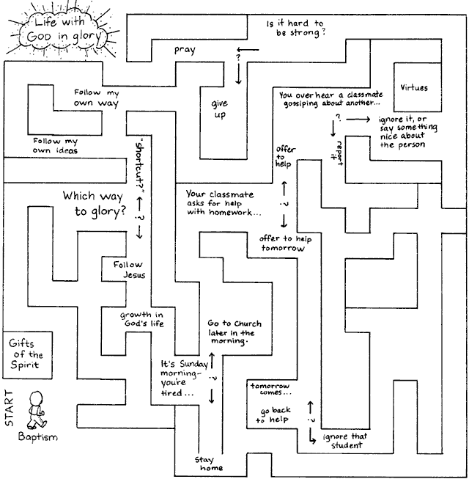
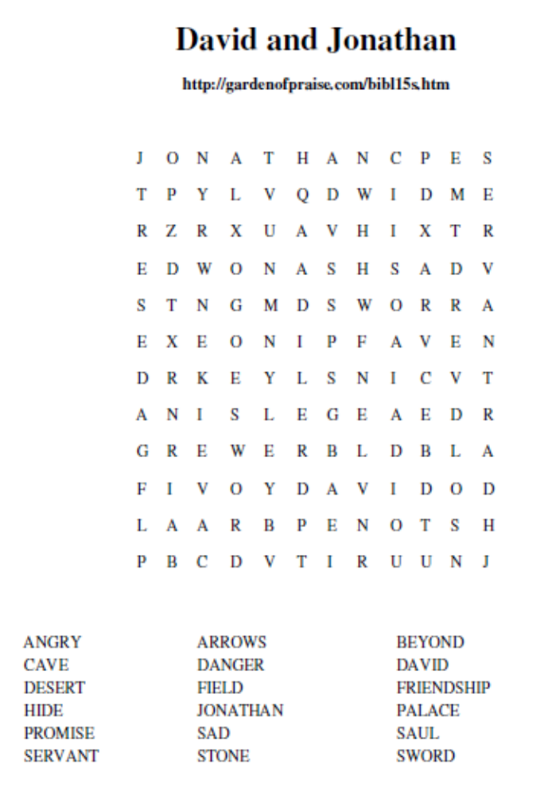
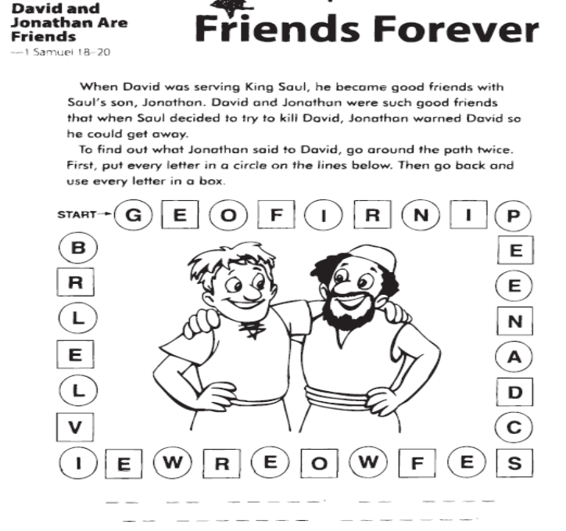
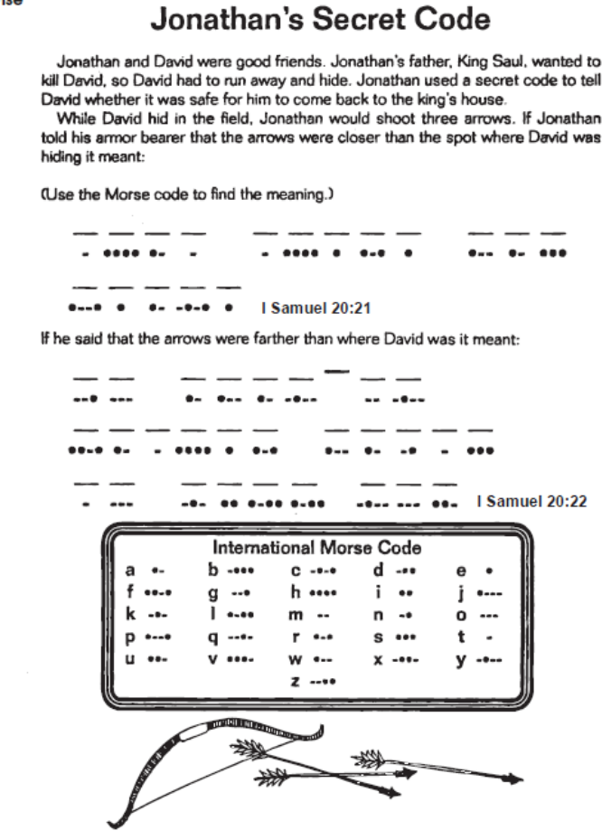

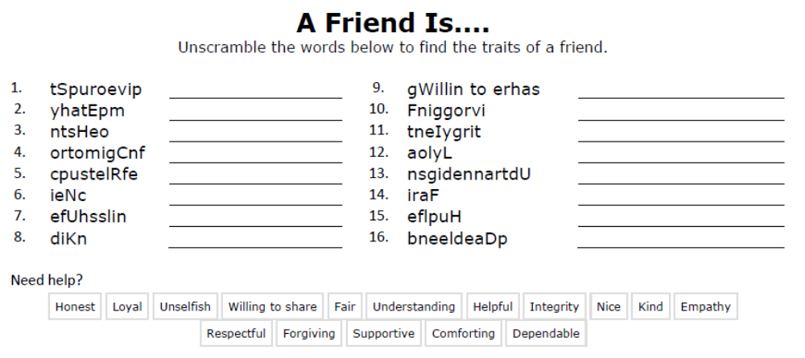
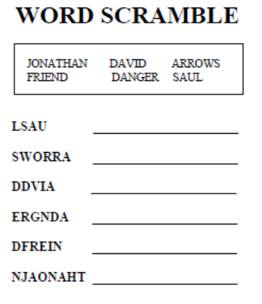
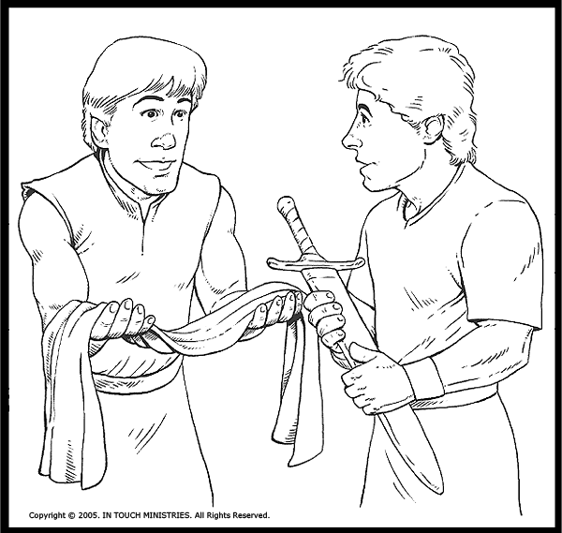

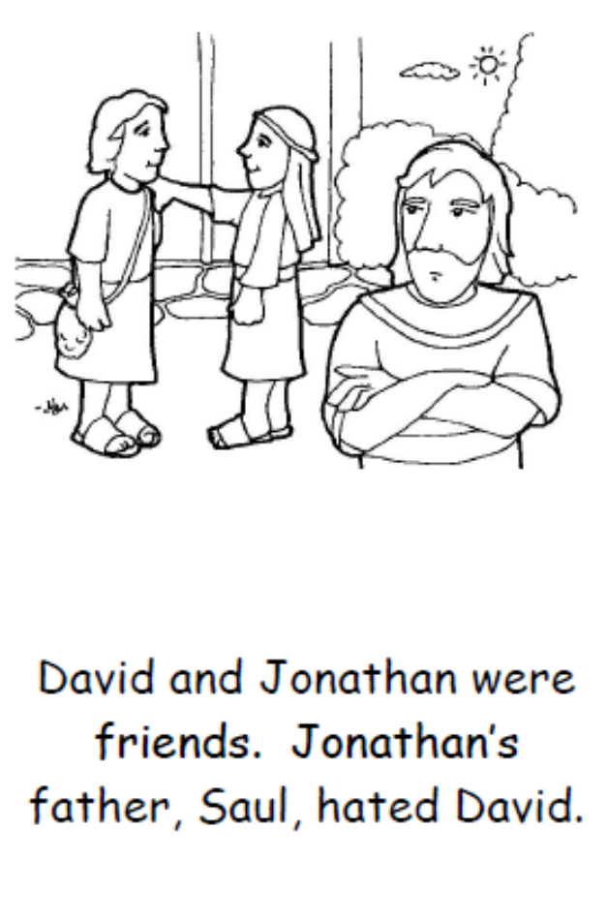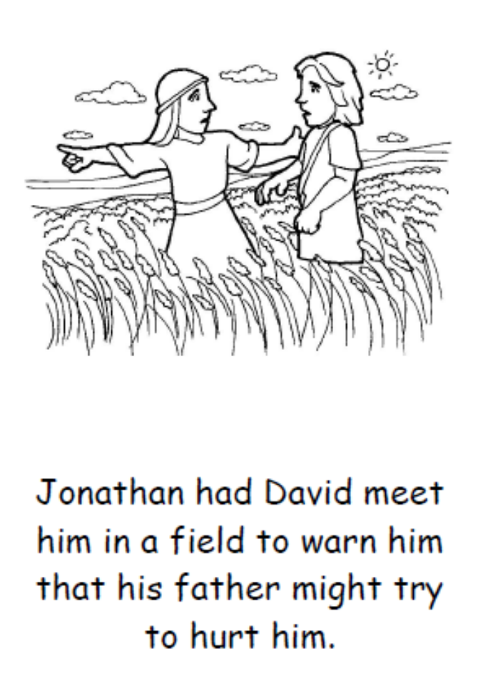
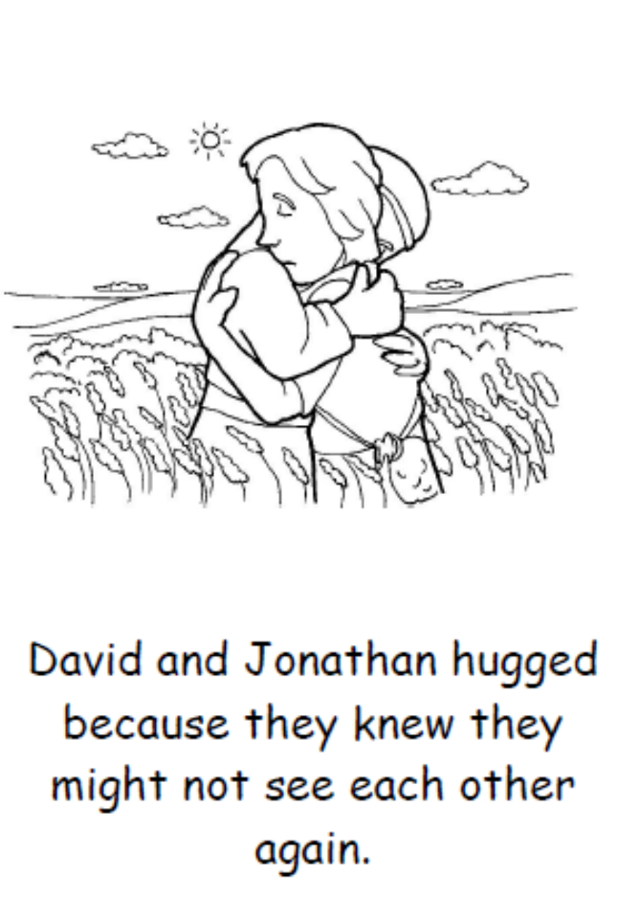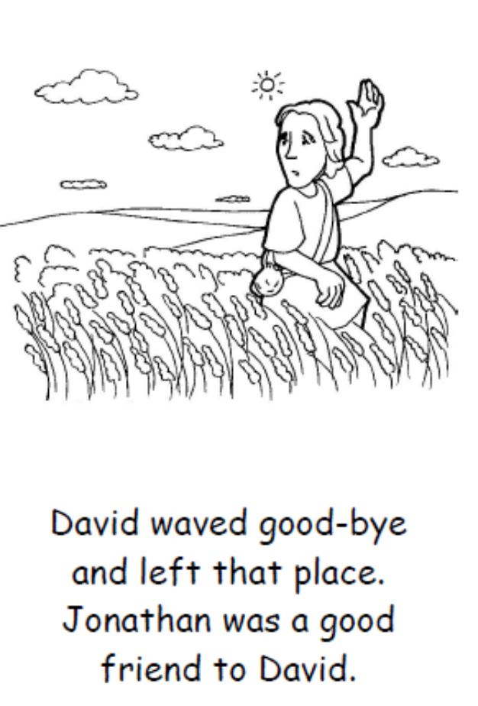
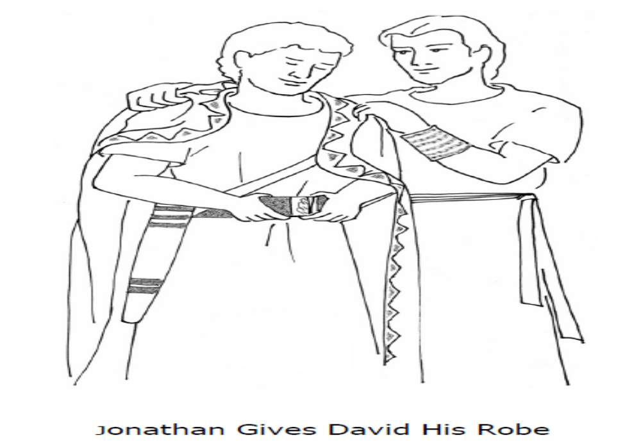
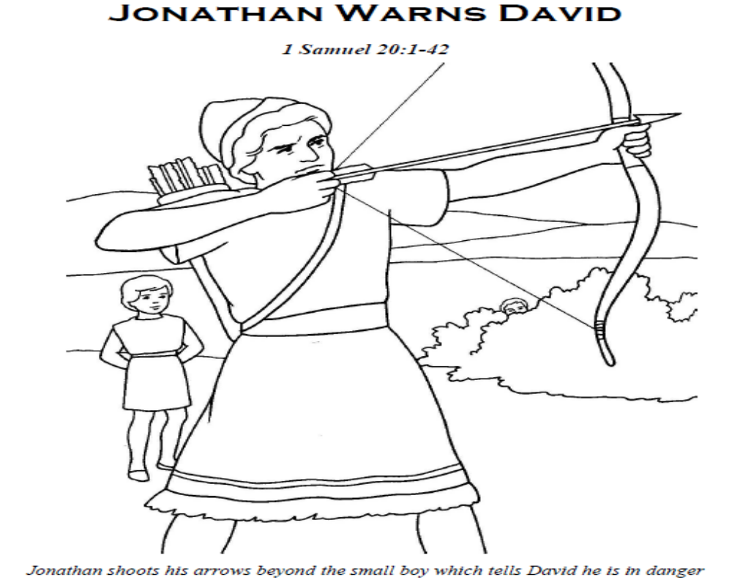
Be A Friend Puzzle
Color then then follow the follow the path on the reverse to be a frend.
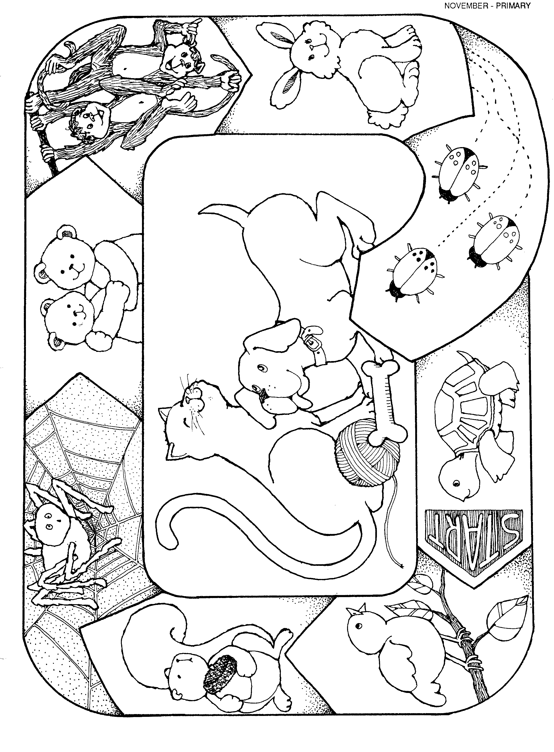

Each piece will help you be a better friend.



