Old Testament, Lesson 30



Valiant Newsletter

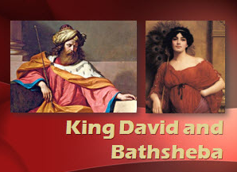

Goal: I will keep my thoughts and actions pure. Keeping my thought pure leads to a clean life, and a clean life leads to happiness. I can look for the Lord’s blessings in my life and be content with what I have. I will be further blessed as I keep the commandments and endure to the end.

Old Testament Lesson 30
King David and Bathsheba
- Read 2 Samuel 11:1-27; 2 Samuel 12: 1-7
- Memorize: The 13th Article of Faith
- How does the following picture help you to remember to follow God’s Commandments?
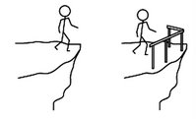
- What does it mean to endure to the end?
- Read Doctrine and Covenants 14:7 what promises has the Lord given for those who keep his Commandments?
Challenge: Choose something uplifting you can think of to replace an undesirable thought..

I Am Glad For Many Things
1. I am glad for many things,
Many things, many things.
I am glad for many things
That are mine today.
2. Thank you, thank you, my heart sings,
My heart sings, my heart sings.
Thank you for the many things
That are mine today.




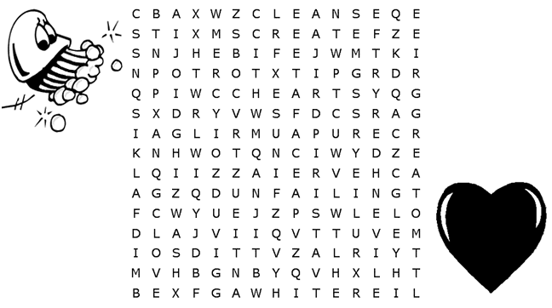
Mercy Wash Whiter Create
Unfailing Iniquity Snow Pure
Love Cleanse Hide Heart
Great Evil Face Spirit

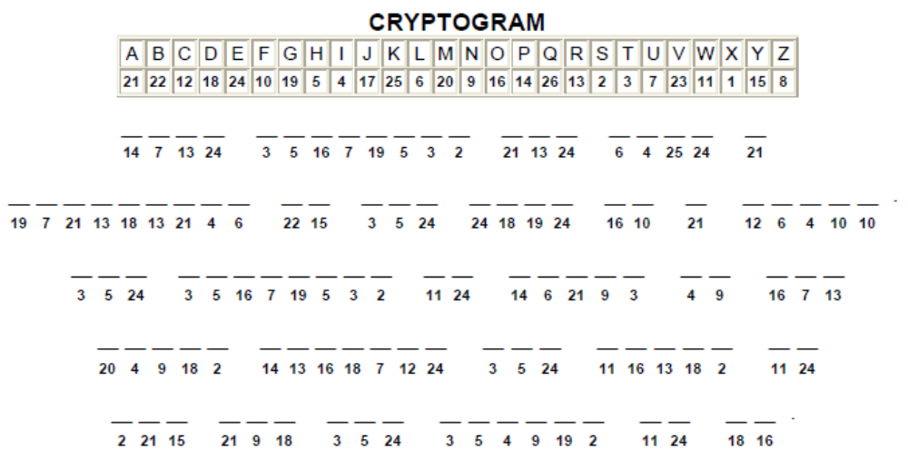

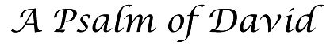
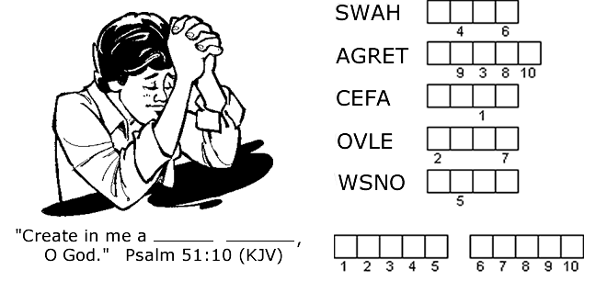
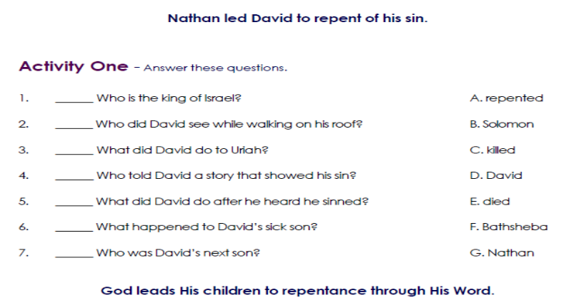

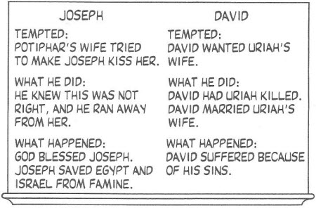
Keep the Commandments
1. Keep the commandments;
keep the commandments!
In this there is safety; in this there is peace.
He will send blessings;
He will send blessings.
Words of a prophet:
Keep the commandments.
In this there is safety and peace.
2. We are His children; we are His children,
and we must be tested to show we are true.
Hold to His promises;
Hold to His promises,
Heeding the prophets:
Keep the commandments.
In this there is safety and peace.

Answers :
Psalm of David - wash great grace snow clean heart
Nathan led David – 1.D; 2.F; 3.C; 4.G; 5.A; 6.E; 7.B

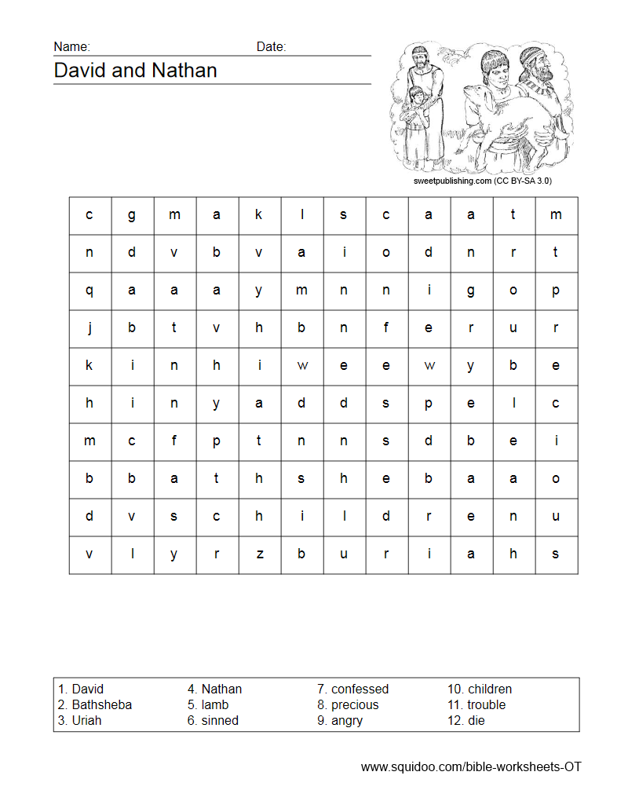

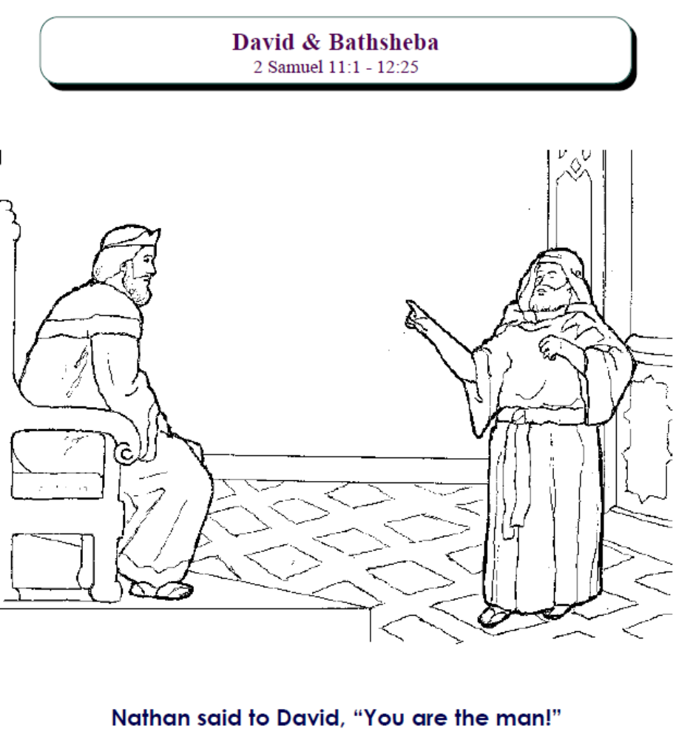
David Lamb Angry
Bathsheba Sinned Children
Uriah Confessed Trouble
Nathan Precious Die
2 Samuel 11:1 – 12:25



