

“It is wise to fear that our

own skills are inadequate

to meet the charge we

have to nourish the faith

of others. Our own abilities,

however great, will not

be enough. But that

realistic view of our

limitations creates a

humility which can lead

to dependence on the

Spirit and thus to power.”



Have extra time in class? Throughout the year,   
 we’ll share some simple time fillers...  
  
   
  
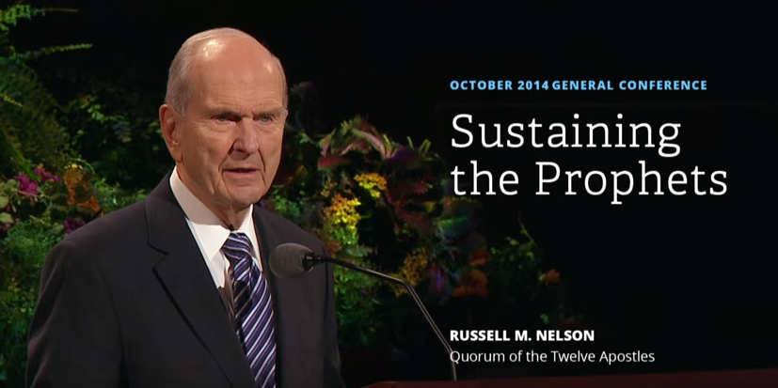  
  
Children enjoy raising their hands to sustain leaders both in church and during general conference. We can begin now to help them understand the significance of this gesture. Briefly review President Russell M. Nelson’s October 2014 general conference talk, “Sustaining the Prophets,” with your class, highlighting key points. Then trace each child’s hands onto cardstock and cut them out. We wrote ideas of what it means to sustain the prophets on the fingers of our cardstock hands and attached our cardstock hands to wooden craft sticks so we could play with them and wave them around! We are hoping that this “handy” imagery will allow us to easily remember what we are promising to do when we raise our hands to sustain the prophets—in general conference and in our daily lives.  
  
* To read President Russell’s talk go here: <http://tinyurl.com/ps5sxmq>   
  
* There is a 2 minute video highlight you could play for your class here: <http://tinyurl.com/pg3g43e>  
  
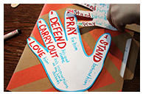

### **-** <http://tinyurl.com/ksograt>

|  |  |  |  |
| --- | --- | --- | --- |
| **Nursery** | **Primary 1** | **Primary 2** | **Primary 4** |
|  |  |  |  |
|  |  |  |  |
|  |  |  |  |
|  |  |  |  |
|  |  |  |  |

#### 

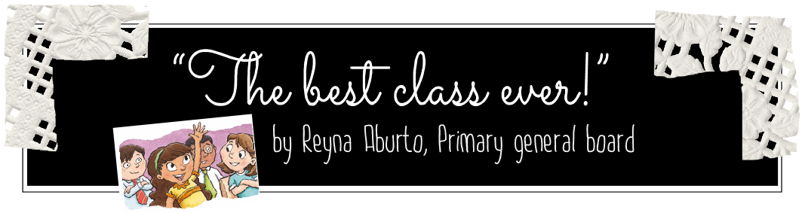  
  
One day my daughter said, “Something amazing happened in seminary today! The teacher hadn’t even started class when a boy raised his hand and asked a question. Then, someone else asked another question, and we kept asking question after question. Everyone participated in trying to find the answers and the Spirit was very strong. It was the best class ever!”

As I have reflected on that experience, I have asked myself: Do we realize how eager our children are to learn? What can we do to help them feel comfortable asking questions? How can we listen to their questions with an open heart? How can we follow the Lord’s example of teaching and help our children find the answers by themselves? What would encourage the students in our class to teach each other?

Lesson 14 of Teaching, No Greater Call counsels us: “Your main concern should be helping others learn the gospel, not making an impressive presentation. This includes providing opportunities for learners to teach one another. When an individual asks a question, consider inviting others to answer it instead of answering it yourself. For example, you could say, ‘That’s an interesting question. What do the rest of you think?’ or ‘Can anyone help with this question?’”

If we allow the Spirit to guide us as we teach our children, we will find ways to help them learn the truths of the Gospel, “for when a man speaketh by the power of the Holy Ghost the power of the Holy Ghost carrieth it unto the hearts of the children of men” (2 Nephi 33:1).  
  
-------------------------------------------------------------------------------------------------------------------------------------------

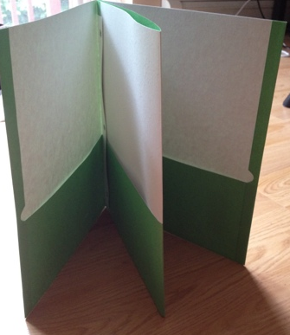  
  
  
  
Do you have folders for the children in your class? Do you need more pockets? Use two folders together. Learn how here: http://tinyurl.com/pys2h9v

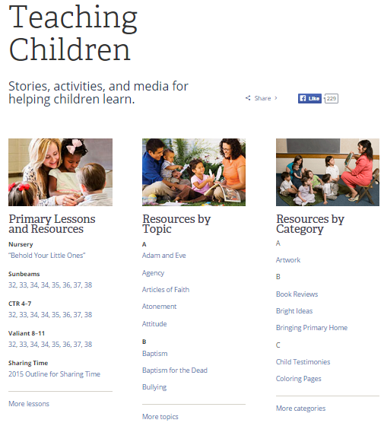  
Did you know the church gives you helps by lesson, topic and category? Check it out at https://www.lds.org/  
children/resources

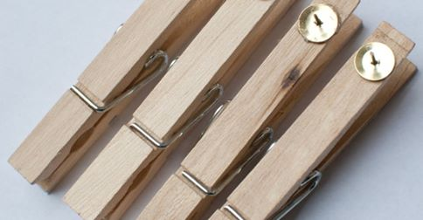   
  
Hot glue tacks to the back of clothespins to hang pictures for your lesson at church. Just push into the bulletin board strip along the top of the chalkboard so you can hang pictures.