**We miss you postcards**  
  
  
  
  
  
  
  
  
Cards to send/take to children in your class who haven't   
been to Primary in a while  
http://tinyurl.com/zhv3uao

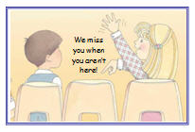

### Image Source: Deseret News

  
  
"Lesson 2: Understanding Those You Teach" - Consider the last lesson you taught. As you prepared and presented the lesson, what did you think about? Did you think about the lesson material? Did you think about those you were teaching? How much did you really know about the individuals you were teaching? If you did not know them, how might knowing at least something about each of them have made a difference in your lesson?  
  
Think about the next lesson you will teach. Try to picture in your mind the setting and each individual who will be there. Perhaps someone who sits in the same place each week comes to mind. What do you know about that person that might help you decide which point to emphasize in the lesson? What experiences has he or she had that might help someone else better understand a gospel principle? Your knowledge of these things will influence your choices as you prepare and present lessons. This is why you need to do more than simply understand your lesson material; you need to understand the people you teach—as children of God, as members of their age-group, and as individuals.

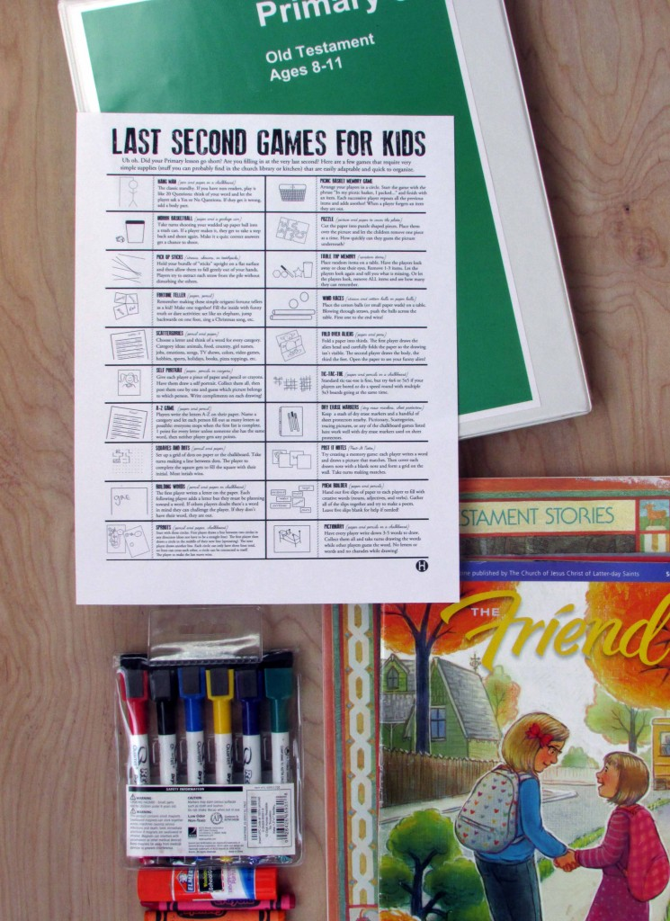  
  
Last minutes games   
when your Primary   
lesson runs short….

**http://tinyurl.com/lbn428n**

#### 

|  |  |  |  |
| --- | --- | --- | --- |
| **Nursery** | **Primary 1** | **Primary 2** | **Primary 4** |
|  |  |  |  |
|  |  |  |  |
|  |  |  |  |
|  |  |  |  |
|  |  |  |  |



  
  
There are so many things in place to help us remain active. I would like to suggest that the ordinary Church classroom is a powerful setting for steady and continued growth in the gospel. Sunday School, priesthood, Relief Society, Young Women, Primary, seminary, and institute classes may be held in dedicated buildings, under a tree, or in a home. But each class is part of a plan for lifelong gospel learning.  
  
 The fundamental curriculum for all classes in the Church is the scriptures —they contain the unchanging doctrines of the kingdom of God. These truths are what brought us into the Church. If we fail to continue learning them, we may not stay. “You shall teach one another the doctrine of the kingdom … that ye may be prepared in all things.”

Elder Boyd K. Packer said, “True doctrine, understood, changes attitudes and behavior.” How do we know which doctrine to teach each week? It is stated in the lesson objective. But how do we come to understand the doctrine in a way that it will change our attitudes and behavior?

In order to really understand, we have to see the way doctrine is applied. In the lesson manuals, the suggested stories, examples, activities, and games are intended to help the learners understand doctrine in real-life settings.

Because the daily life of people varies so much in the 160 different countries where we have organized classes, the stories and examples in the manuals may sometimes confuse the learners. Teachers can prayerfully make adaptations, always taking care that the learning activities chosen truly reflect the doctrine.

A teacher’s goal is greater than just delivering a lecture about truth. It is to invite the Spirit and use techniques which will enhance the possibility that the learner will discover the truth for herself and then be motivated to apply it. Although some seem to be born teachers, teaching skills can successfully be learned. Where can you go as a teacher to enhance your skills? Could you watch and learn from others? Perhaps approach an admired teacher, asking him to observe and offer suggestions? What about your Primary presidency, if you are a Primary teacher, or your Sunday School presidency, if you teach Sunday School? Asking your ward teacher development coordinator for regular and specific help would put you in touch with a multitude of resources. We don’t have to struggle alone in this Church. There is help everywhere. We can prayerfully and courageously seek to learn and practice new techniques.

Can you imagine hundreds of thousands of classrooms every Sunday, each with a teacher who understands that “the learning has to be done by the pupil. Therefore it is the pupil who has to be put into action. When a teacher takes the spotlight, becomes the star of the show, does all the talking, and otherwise takes over all of the activity, it is almost certain that he is interfering with the learning of the class members.”

A skilled teacher doesn’t think, “What shall I do in class today?” but asks, “What will my students do in class today?”; not, “What will I teach today?” but rather, “How will I help my students discover what they need to know?” The skilled teacher does not want students who leave the class talking about how magnificent and unusual the teacher is. This teacher wants students who leave talking about how magnificent the gospel is!

Learning occurs best in an atmosphere of trust and safety. This means that each person’s questions and contributions are respected. When we feel safe and included, we can ask questions that will help us to understand the gospel. We can share insights and faith that might help someone else. 9 We can stumble without embarrassment as we try to apply the lessons taught. Conversely, when we feel that we must protect and defend ourselves or seem more righteous than we are, our energy is used counterproductively and our learning and the learning of others is severely limited. Maintaining a climate of trust and safety is a responsibility the teacher and the learners share.

I have heard Sister Janette Beckham, Young Women general president, talk simply about teaching a class. She says: “It is the teacher’s responsibility to introduce the lesson and help lay the groundwork. The middle part belongs to the students where they participate and work toward understanding and application. Then the teacher must watch the time, because she owns the last few minutes of class. She has a responsibility to clarify and summarize the doctrine taught so that learners will not leave confused about the message. Then she can bear personal testimony of the principle under discussion.” President Hinckley encourages us: ***“We are all in it together, all of us, and we have a great work to do. Every teacher can be a better teacher than he or she is today.”*** I would add: ***Every learner can be a better learner than he or she is today. And every classroom can be a better classroom.”***  
  
*\* This article was shortened to fit on this page. If you would like to read the whole article go here:* <http://tinyurl.com/pne6rjj>

### **-** <http://tinyurl.com/ksograt>