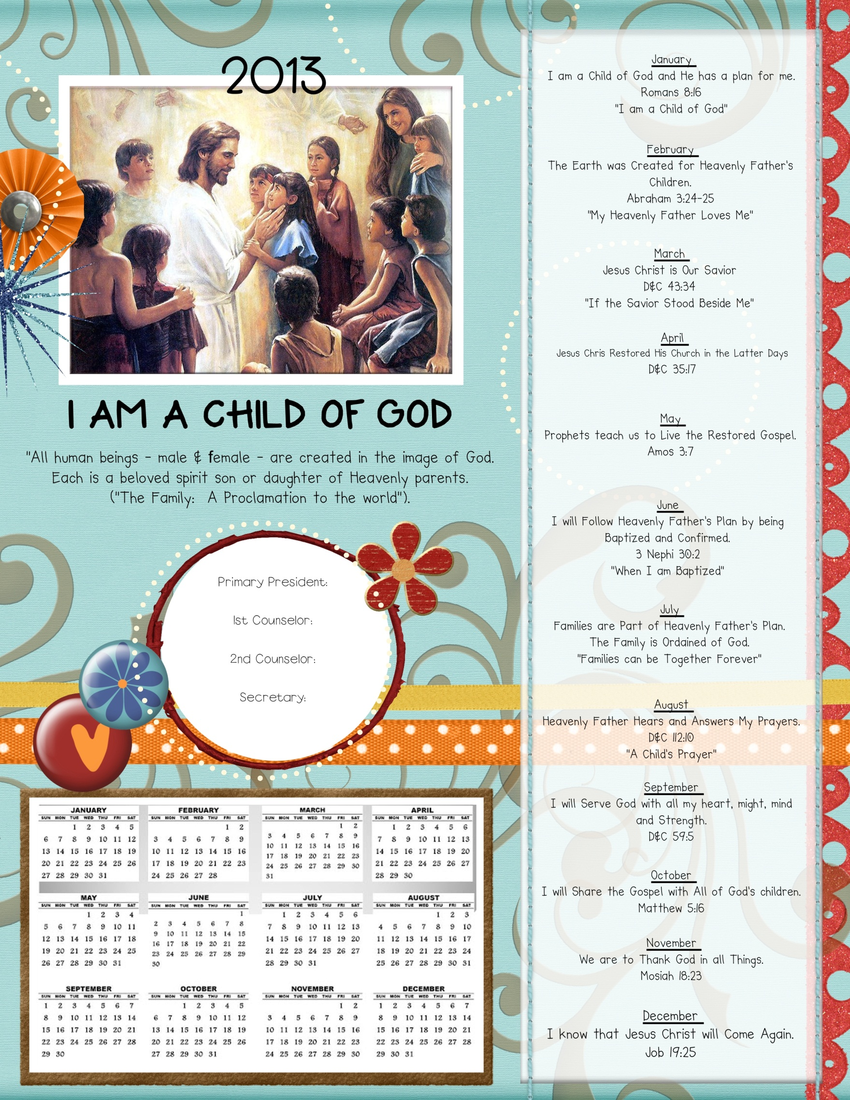

“Latter Day Prophets”

Name 555-5555

Name 555-5555

Name 555-5555

Name 555-5555

“I Belong to the Church of Jesus Christ”