  
The physical setting of the classroom can distract from teaching and learning. When class members enter a classroom or other teaching setting that is disorderly or uncomfortable, they are less likely to give their full attention to the message of the lesson. Carefully planned physical arrangements can help reduce distractions. For example, we should arrange chairs so learners will be able to see us, the chalkboard, and each other. Such a classroom arrangement enhances the teacher’s ability to teach and the learners’ ability to participate and learn. Controlling the temperature of the room, where possible, can help everyone be comfortable. We can prevent and solve discipline problems by following basic principles of gospel teaching. Point out that when we create and maintain a learning atmosphere, we help prevent distractions and solve discipline problems. The most important thing we can do to accomplish this is to implement the principles of gospel teaching that are taught in this course. These principles are: Love those you teach, teach by the Spirit, teach the doctrine, invite diligent learning, prepare every needful thing and use effective methods. As teachers, we should regularly examine ourselves and our teaching to make sure that we are applying each of these principles.

Encourage your Primary class to watch the First Presidency Christmas devotional with their families. Go to LDS.org to get details on date, time and how to view it.

Handprint Baby Jesus in Manger

Snowy days are big craft days around our house - especially with a new baby. While thinking of Christmas themed projects, inspiration hit for this sweet handprint craft. It also gave me the opportunity to talk with my 2 year old about baby Jesus being the reason for the season :).

You will need:
- paper
- paint: brown, yellow, peachy pink, white, pink
- sharpie

I started with brown paint on my child&rsquo;s hand for the manger. Once dry, we used his thumb print for baby Jesus&rsquo; head. An adult or older child can then paint the straw and the little body. Once dry, we drew on a sweet face with a brown sharpie and dotted on pink cheeks. That&rsquo;s it!

Happy painting!
Amy  
**Handout idea – Manger Handprint**(could be made   
into an ornament)  
http://tinyurl.com/hh6yvp4

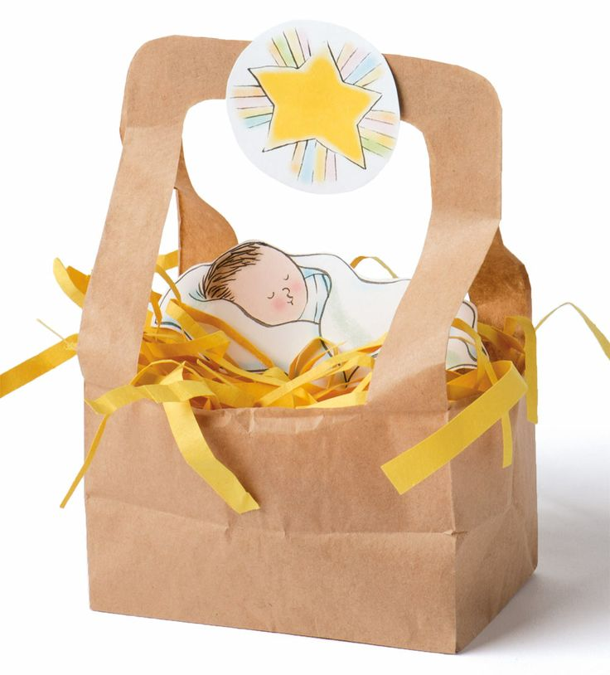  
**Handout idea – Manger Scene**   
(from the Friend Magazine)  
  
http://tinyurl.com/grjkuwl

### http://www.lds.org/bc/content/ldsorg/home/first-presidency-christmas-devotional-2012-Lvl1-v2.jpg

#### 

|  |  |  |  |
| --- | --- | --- | --- |
| **Nursery** | **Primary 1** | **Primary 2** | **Primary 4** |
|  |  |  |  |
|  |  |  |  |
|  |  |  |  |
|  |  |  |  |
|  |  |  |  |

[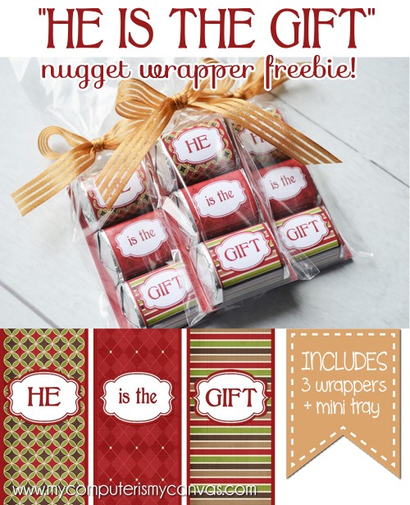](http://2.bp.blogspot.com/-DPh1ZQJOxYs/VJL3sK_atDI/AAAAAAAAUHc/1OHMbFup1To/s1600/FREEBIE---HE-is-the-GIFT-004-5x7.jpg)  
  
  
  
  
  
  
  
FREE PRINTABLE   
CHRISTMAS GIFT IDEA:  
**http://tinyurl.com/mx2tth3**



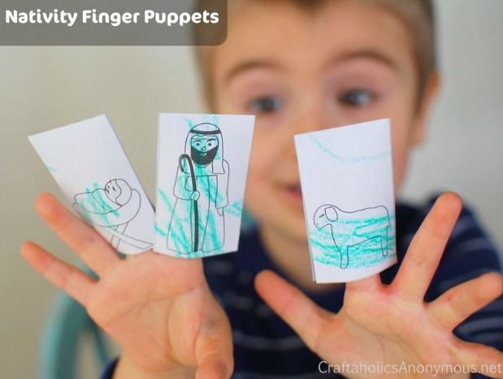  
  
http://tinyurl.com/hhqps6e

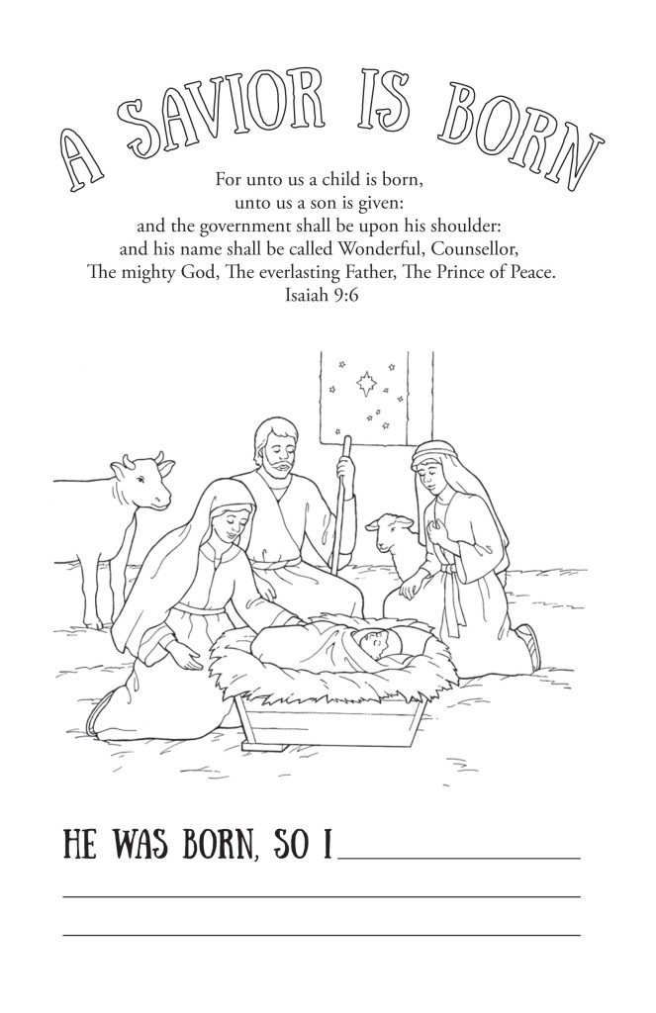  
**A Savior is Born coloring page**  
<http://tinyurl.com/hp5hkqn>

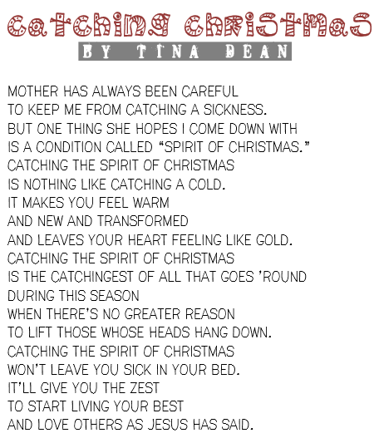

*The candy cane turned*

*upside down,*

*is the letter J.*

*To remind us of*

*the baby Jesus*

*born of Christmas Day!*  
  
**SOURCE:**  
  
http://tinyurl.com/h72368q

