**Heart Bookmark** - http://tinyurl.com/jr942w8

### http://2.bp.blogspot.com/-iqstR52Lyg0/TxzCmlnMVlI/AAAAAAAABmE/iO7qDrCH8v0/s640/heart_bookmarks4.jpg

For a copy of “Standing up for Caleb” go to: http://tinyurl.com/ofwosvn



TIME FILLER IDEA #2  
 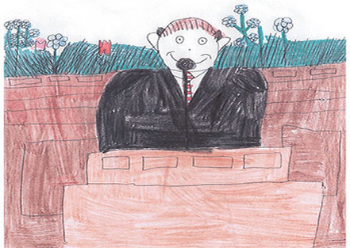  
  
If you have extra time, have your class draw a picture that pertains to your lesson or a past lesson. Then send the children home with a copy of the permission slip (required for submission) and mailing envelope so they can mail it to the Friend Magazine. Who knows, they could get selected for publication!   
  
  
  
*(Two copies of the permission slip is located on page 2 for your convenience)  
  
P.S.*  
  
The Friend Magazine has decided to create an album to include more of the artwork submitted to them that doesn’t fit in the magazines. They post ten new submissions every week at childart.lds.org

### Have extra time in class? Throughout the year, we’ll share some simple time fillers... TIME FILLER IDEA #1 For many children, Valentine’s Day is an exciting time of class parties, pretty cards, and sweet treats. Unfortunately, for older children this holiday can be about excluding others and publicly picking favorite friends.

If you have extra time in class, take the opportunity to talk about loving one another and including everyone. You could read “Standing Up for Caleb” from the March 2009 Friend, a story about a boy who includes someone different.

#### 

|  |  |  |  |
| --- | --- | --- | --- |
| **Nursery** | **Primary 1** | **Primary 2** | **Primary 4** |
|  |  |  |  |
|  |  |  |  |
|  |  |  |  |
|  |  |  |  |
|  |  |  |  |



10 principles every teacher should know   
 (Taken from August 2014 Ensign)   
  
In addition to strengthening the power of learning and teaching in the home, we can also strengthen the classroom experience at church. As teachers apply these 10 principles, they will foster conversion in the lives of those they teach.

1. Counsel with parents, who have the primary role as teachers, to identify needs of class members, and then teach to those needs.

2. Prepare and teach by the Spirit. Identify questions and learning activities that will provide Spirit-led discussions and nurture class members spiritually.  
  
3. Teach people, not lessons.  
  
4. Focus on the core doctrines of the gospel.  
  
5. Teach one or two key principles in depth rather than trying to cover all the lesson material.  
  
6. Invite the Spirit by letting everyone participate (see [D&C 88:122](https://www.lds.org/scriptures/dc-testament/dc/88.122?lang=eng#121)).  
  
7. Include a powerful invitation to act—not just something to go home and read but something to go home and live.  
  
8. Bear your testimony about the doctrine—at the end of the class and whenever the Spirit prompts you.  
  
9. Live the gospel, and “set in order” your own home (see [D&C 93:43–44, 50](https://www.lds.org/scriptures/dc-testament/dc/93.43-44%2C50?lang=eng#42)).

10. Find ways to let the teaching continue through informal moments in everyday life.   
  
  
  
  
  
  
  
  
  
------------------------------------------------------------------------------------------------------------------------  
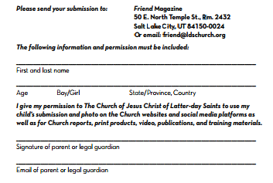 

  

<http://tinyurl.com/h2xv2sl> <http://tinyurl.com/n3tpgd9> http://tinyurl.com/hwtge6j