A

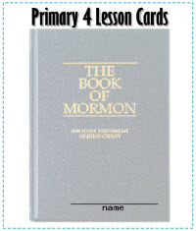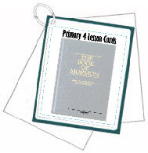

*Lesson Cards/Handouts that   
correlate with the*   
**Primary 4**Lesson Manual  
  
<http://tinyurl.com/jhxr4dl>

For each set of candy bar scriptures, you’ll need: red ribbon/twine, two mini chocolate candy bars (like Hershey Treasures or something similar), a strip of paper, wrapping paper, or sturdy material to place scriptures in (see above picture), scotch tape and strip of white paper (you can leave this blank and let the children write on them or you can print your favorite verse.

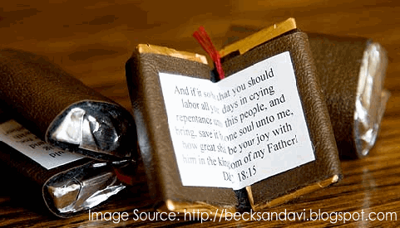  
craft Idea:

**Understanding those you teach** by Mary Durham - “It’s the beginning of a new year, and perhaps that means you are starting to teach a new class of Primary children. It’s a time when I like to ask myself some important questions: What challenges do these children face? What questions do they have about the gospel? What experiences do they have in common? Pages 33-34 of Teaching, No Greater Call remind us how important this understanding is: “How much did you really know about the individuals you were teaching? … Although the people you teach have many common characteristics, they come from a wide variety of backgrounds and circumstances. No two are exactly alike. They have different abilities, likes, and dislikes. They have experienced different joys and opportunities, and challenges. … As you come to know and understand each person, you will be better prepared to teach lessons that speak to their individual situations.”   
  


### ________________________________________________________________________________ ________________________________________________________________________________ ________________________________________________________________________________

### Did you know that LDS.org has several videos for Primary Teachers to use as part your lessons? To see all the options, go to <http://tinyurl.com/qdrly3m>

Have extra time in class? Throughout the year, we’ll share some simple time fillers...



#### 

|  |  |  |  |
| --- | --- | --- | --- |
| **Nursery** | **Primary 1** | **Primary 2** | **Primary 4** |
|  |  |  |  |
|  |  |  |  |
|  |  |  |  |
|  |  |  |  |
|  |  |  |  |

## *by Reyna Aburto, Primary general board* A friend of mine recently related the following experience to me. He said: “Years ago, I was called to teach the older boys in our ward Primary. My first reaction was that this would be an easy assignment as far as lesson preparation was concerned.  All I needed to do was glance through the lesson and look for the activities that were recommended for my Primary children. After a couple of weeks doing this, I realized the seriousness of my mistake. I remembered a comment by President David O. McKay. He indicated that what every teacher should do was: 1) get into the subject; 2) get the subject into him or herself; then 3) lead, not drive, the students to have the same kind of experience the teacher had. “So, I began studying the Primary manual lesson for myself, seriously considering all the scripture references and general authority quotes with myself in mind. I was pleasantly surprised at the spiritual experience I had for myself from the Primary lesson manual. Then, and only then, did I begin to look at the lesson with the students in mind, thinking about what they could do to have a similar experience. Once I did that, I began seeing some significant spiritual growth in some of my Primary children.” As we teach children, our honest efforts to apply in our life the gospel principles we teach will help us find effective ways to invite the children do the same. We will then feel the joy of walking on the path of salvation together. Sister Virginia H. Pearce said: “A teacher’s goal is greater than just delivering a lecture about truth. It is to invite the Spirit and use techniques that will enhance the possibility that the learner will discover the truth [and] be motivated to apply it. … A skilled teacher doesn’t think, ‘What shall I do in class today?’ but asks, ‘What will my students do in class today?’; not, ‘What will I teach today?’ but rather, ‘How will I help my students discover what they need to know?’” (Teaching, No Greater Call, page [61](https://www.lds.org/manual/teaching-no-greater-call-a-resource-guide-for-gospel-teaching/lesson-13-helping-individuals-take-responsibility-for-learning-the-gospel?lang=eng)). ------------------------------------------------------------------------------------------------------------------------------------------------------------------------------------------- *How did you welcome your students to class and let them know you were their teacher? How did you make them feel special? Are you doing something this year with your class that has really helped?* - My husband and I team teach CTR 7 (7 year olds turning 8). We took each of them a number 8 sugar cookie and introduced ourselves to them and their parents. - I hand deliver a letter welcoming them to their new class with the schedule, room # and my contact information. - One thing I do every week is go around the circle and say one thing we were excited about or did that week. It made them feel special and it help cut down the chatter! - We have a CTR moment at the beginning of class. They can share with us something they did throughout the week when they remembered to choose the right. It really helps get the children settled down and ready for the lesson. It also helps encourage them throughout the week to CTR because they know we will be asking on Sunday.

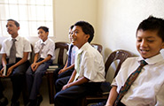

**TIP FROM Michelle Selui: Establish your rules and consequences the first Sunday. Get know your class and pray for them.**

"Every week I post a picture of the Savior on the outside of our classroom door. Before I let my little 6 year olds into the classroom, I ask them to enter one at a time, reverently, and then the LAST in line gets to "invite" the Savior into our classroom to join us. I then tape the picture up on the wall where the Savior can see us. This has added a huge change in the reverence in our classroom. The children feel special that THEY got to invite Him in to be with US." (Idea by Nancy Jarman)

