

  
  
As a Primary teacher or leader, you can assist parents in their efforts to teach the gospel to their children. Tell parents what you are teaching in your class so they can reinforce those gospel principles in the home. Encourage children to share with their family what they are learning. In family home evenings, they can share songs, scriptures, games, and principles they learn in Primary classes or activities. Occasionally you might send home reports on the lessons or activities in which they have participated to help reinforce what the child has learned. You could also let parents know when their child has been particularly helpful or when their child is assigned to pray or give a talk. You can invite parents to share their experiences or their testimonies as part of a lesson.

  
  
   
  
Children with disabilities often have difficulty transitioning from one activity to another. Transitions such as going from sacrament meeting to a Primary class can be noisy, crowded, and confusing. They may trigger anxiety, acting out, and other behaviors. Here are some tips that can help children make smooth transitions at church.  
  
**Prepare the child:** You can help make transitions less confusing by letting the child know what is going to happen. For example, you might say, “Now we are going to sing a song, then say a prayer, and then go to Primary.” **Avoid the rush:** Transitions between church meetings can be chaotic and troubling. It might take some special coordination, but waiting until the crowd has thinned before you go to a classroom may be helpful.  
 **Practice:** Help your child become accustomed to the routine transitions that happen at church. For example, you could go to the chapel on a night the church building is open and practice going from the chapel to the child’s classroom and from the child’s classroom to the Primary room.

#### 

|  |  |  |  |
| --- | --- | --- | --- |
| **Nursery** | **Primary 1** | **Primary 2** | **Primary 4** |
|  |  |  |  |
|  |  |  |  |
|  |  |  |  |
|  |  |  |  |
|  |  |  |  |

### **PIONEER GAME:** The whirligig, or buzz saw, will spin and hum while you pull your arms apart and push them together. See how long you can keep it going!

### You’ll need a piece of string about twice as long as your arm and a large button with two holes.

### 1. Thread the string through the button holes and tie the ends in a knot, forming a loop.

### 2. Hold each end of the string so that the button hangs slack in the middle. Swing the button in a circle to tightly wind up the string.

### 3. Pull your hands apart and push them together again. Watch the button whirl and sing!

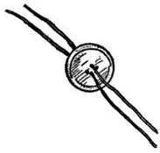

 *by Tamra Flake Kriser / September 2003 Friend Magazine*  
  
 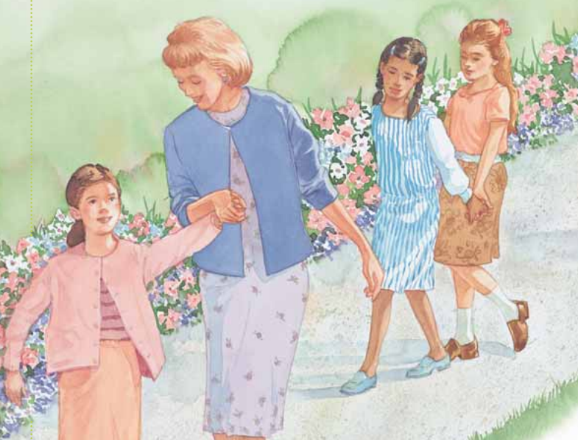  
 I am the good shepherd, and know my sheep (John 10:14)  
  
Mandy was a friend in my ward when I was growing up. We went to Primary together. She had no brothers or sisters and lived with her mother, who seldom went to church. In those days, Primary was held on a weekday afternoon. One time while we were waiting for Primary to start, some of the girls in our class said some things that hurt Mandy’s feelings. She began to cry and went home. Later in class when our teacher was taking roll, she paused when she came to Mandy’s name and asked if anyone knew where she was. The room became silent, and a couple of girls began to squirm in their chairs. It didn’t take long for our teacher to learn what had happened. Our Primary teacher set aside the lesson she had prepared and taught a lesson I have never forgotten. She stood up and told us that we were all going to Mandy’s house to apologize and to mend our friendships. We were silent as we walked the two or three blocks to Mandy’s house. At first, it was awkward when she came to the door with red and swollen eyes. But apologies were given and accepted. Our friendships were renewed, and soon we were all in tears. Mandy came back to Primary that day. She continued to come every week and remained faithful as a youth. When she grew up, she married a returned missionary in the temple. Today she and her husband are raising a beautiful [family](http://www.mormon.org/values/family). They remain active and involved in the Church. I am thankful for a Primary teacher who cared enough to teach us about love and repentance by taking us to find a lost lamb. Through her example, I came to know just how much Mandy—and each one of us—mattered, not just to her, but also to Heavenly Father and [Jesus Christ](http://www.mormon.org/beliefs/jesus-christ). I have never forgotten that lesson.

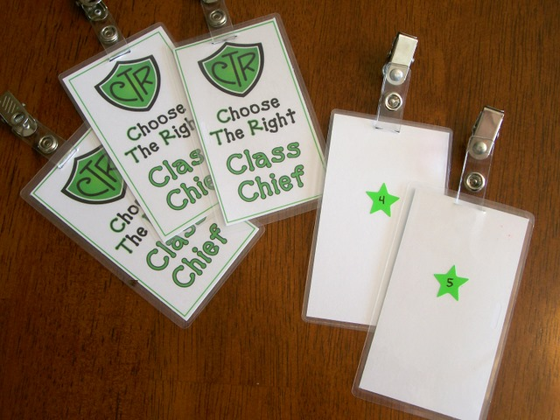  
  
**REVERENCE BADGES** *and Reverence Helps  
by Maria Eckersley*  
http://tinyurl.com/zudornu

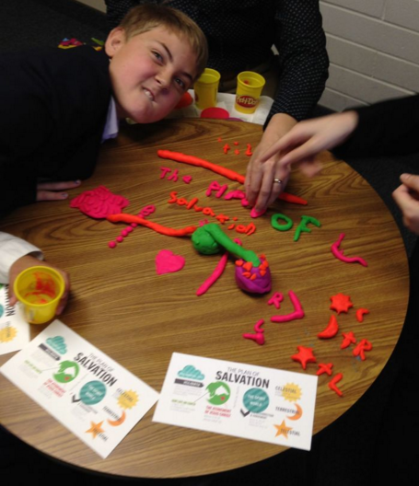  
Consider using playdough to help reinforce the   
principles in your lesson. For more information on this picture, see this post: http://tinyurl.com/nlu4wkn