  
As a teacher, you can do much good by listening. When you listen, you focus your teaching on the needs and interests of individuals. You demonstrate your respect for their ideas, opinions, and experiences. You show that you care about them individually. When they know that their insights are important to you, they are more likely to:

• Be receptive and enthusiastic.

• Share thoughts and experiences.

• Learn diligently.

• Live what they learn.

Some may suppose that listening attentively to one member of a group means ignoring the others and doing them a disservice. This is not so. Listening carefully to one person helps the others know that you care about individuals. And as you listen to family members or class members one at a time, you set an example for others to do the same.

Those of us who serve in Primary have the sacred opportunity to bless and strengthen families, both the families of those we serve and our own families. We encourage Primary leaders and teachers to meet together and find ways your Primary can help families. Please consider how to help:

. Children learn gospel principles and live those principles.

. Primary leaders and teachers strengthen their own families.

. Children share with their families what they have learned in Primary.

. Parents understand and reinforce the principles taught to their children in Primary.

. Primary leaders minimize the time that parents who serve in Primary are required to be out of their homes to fulfill their callings.

In discussing ways your Primary can strengthen families, consider these questions: What can we do to better teach the gospel to children and help them live it? How can we encourage children to strengthen their families? How can we help parents understand what principles are being taught in Primary? How can we protect the time of families?

President Boyd K. Packer said: “In Church we are taught the Great Plan of Happiness. At home we apply what we have learned. Every call, every service in the Church brings experience and valuable insights which carry over into [family](http://www.mormon.org/values/family) life” (“Parents in Zion,” Ensign, Nov. 1998, 23).   
  
Primary’s simple gospel curriculum and the [Holy Ghost](https://www.lds.org/topics/holy-ghost?lang=eng)’s influence can strengthen every Primary leader and teacher. In turn, we can share those blessings with our families. Let us each identify ways our callings can bless our families. Primary leaders and teachers fulfill an important responsibility in the Lord’s Church. They love and teach those who are the future mothers and fathers in the kingdom of God on earth. May we all be strengthened in our callings and in our families.

### The church has helped indexed its content to correspond with each lesson manual. Go to the link below and click on the manual and lesson you are teaching and it will list additional resources: <https://www.lds.org/children/resources>

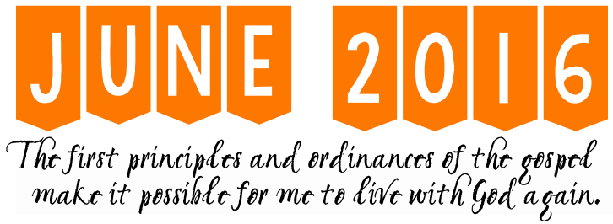

|  |  |  |  |
| --- | --- | --- | --- |
| **Nursery** | **Primary 1** | **Primary 2** | **Primary 4** |
|  |  |  |  |
|  |  |  |  |
|  |  |  |  |
|  |  |  |  |
|  |  |  |  |

#### 

  
  
  
  
I said, "Were you in my class when I used to stand at the door?" And I got that far, and he said, "And you told us that you loved us?" And he said, "Oh, yes, Sister Madsen. I was in that class." I think it was about 10 years ago that I had such a wonderful experience as a Sunday School teacher. I'd been teaching the 17-year-olds for, I think, five years then. And I was sitting in sacrament meeting. In fact, it was during the sacrament. And I had an interruption of my thinking.

And this prompting said, "Tell each one of them that you love them." And I thought, "I tell them all the time as a class that I love them. I finish my lesson with testimony. I tell them how much I love them and to go out there and be good and things like that." But then the prompting came again: "No, tell each one of them that you love them."

So I went down the hall that day thinking of that. It was still in my mind. I got into class. We had a good discussion. We talked. And I did truly love them. And I thought--as the class went on, I thought, how am I going to implement what I heard in my heart and my mind? So I stationed myself after the closing prayer at the door. They could not get by me without shaking my hand.

And so I shook their hands and looked them in the face and said, "I love you, James. I love you, Jill." And the boys kind of looked at different corners of the room and didn't meet my eyes. But it was OK. And the girls, some of them sort of smiled and hugged me a little bit and laughed.

The next week came, and I thought, I need to do that again. It wouldn't be a prompting that would come just for one lesson. So I started doing it every single week. And it was remarkable how things changed over time.

It was so beautiful. We had wonderful classes together. And the Spirit was strong. And it was great. When we'd be leaving, there'd be this wonderful, good feeling. And it wasn't long until the girls were hugging me and saying, "I love you too, Sister Madsen." And the boys were not hugging me. But they would sometimes even look in my eyes and say, "Well, I love you too."

I had such an interesting experience yesterday. One of those boys came back to sing in our ward. And he brought his wife and his beautiful young daughter with curly hair. And you have this wonderful feeling when you've been a Sunday School teacher. You look at them at you think, oh, he was one of mine! And I asked him. I said, "Were you in my class when I used to stand at the door?" And I got that far, and he said, "And you told us that you loved us?" And he said, "Oh, yes, Sister Madsen. I was in that class. And I remember the first time you did it. And I remember how awkward we were, how awkward we felt, and how awkward I felt. And I wasn't sure anybody liked me, let alone loved me.

And when you said that to me week after week after week, I was looking forward to coming down to class because it was so predictable. It didn't matter if anybody else in the world liked me that week. But I knew that you loved me because you looked me in the face and told me." It was one of the sweetest experiences of my life to have that conversation with him yesterday. He said, "I knew someone is waiting there who's going to tell me that she loves me."

IMAGE/IDEA taken from **http://tinyurl.com/hj2ra3b**

[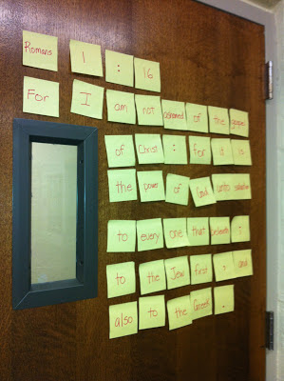](http://1.bp.blogspot.com/-rIT6NCOCMmE/UQB26XMTSCI/AAAAAAAAQvg/DUgW3mJ-5p8/s1600/IMG_2299.jpg)

Depending on the age of your Primary class, it might be fun to have a scripture scramble as a way to introduce the lesson or a key scripture. Divide the post it notes (with a word, number, or punctuation mark) evenly between all the children. Place several on each child’s chair as they enter the room. Have them work together to unscramble the scripture or sentence.

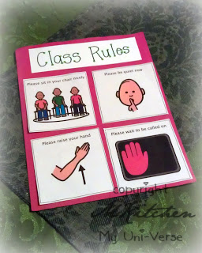  
Does your class have established rules?   
Better late than never! If you need   
some ideas, check out this post:  
<http://tinyurl.com/zjgzvkv>