**Primary 2  
Lesson 21**

CTR NEWSLETTER



**I Can Be Reverent**

Follow the examples of reverence in this maze to the picture of Jesus. When the picture shows Shelley being reverent, choose the path that the arrow points to. When the picture shows Shelly not being reverent, do not follow that arrow.

(Illustrations by Dilleen Marsh; *Christ’s Image,* by Heinrich Hofmann, courtesy of C. Harrison Conroy Co. Maze found on [www.lds.org](http://www.lds.org) )

Christ Blessing the Nephite Children by Ted Henninger

­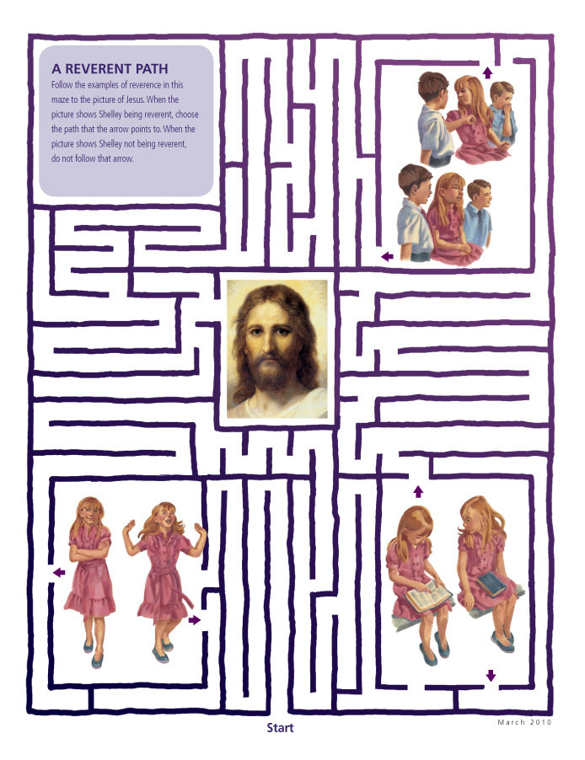­­

*All pictures and illustrations were found on www.lds.org*

How can you show reverence at home?

How can you show reverence at church?

