With Easter just around the corner, March 27th, here is another idea to help your class remember the true meaning of Easter. “The evening before Easter, a Primary teacher placed 12 Easter eggs in the front yard of each child in her class…. “ (Read the full idea here: <http://tinyurl.com/l6e3yxd> )

[](http://4.bp.blogspot.com/-5oUFOno3_pg/UVi1CFWWwVI/AAAAAAAAFxc/St1whYkSY_w/s1600/fanta1.jpg)  
  
  
  
  
Need a motivator to encourage your Primary class to watch General Conference? Here’s one idea: <http://tinyurl.com/pm2yfxg>

### We often count down the days until Christmas with an advent calendar that helps children learn about the true meaning of the season. Why not do the same for Easter? Help your class focus less on candy and more on Christ with an activity found here: <http://tinyurl.com/ozrlrxs> (from March 2015 Friend Magazine). Starting Sunday the 20th, match the picture with the description, scripture, and question for each day. Or go through them all at once and use the questions as talking points for them to do a ready-made family home evening for their family! By focusing on the life and mission of Jesus Christ, our families can feel the joy of Easter more than ever before.

Have extra time in class? Throughout the year, we’ll share some simple time fillers... CTR Rings!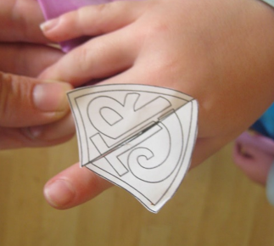  
Craft Idea: <http://tinyurl.com/p35lp2w>. You could make these out of craft foam or laminate them with a thin laminate after they color them to make them last longer.

#### 



|  |  |  |  |
| --- | --- | --- | --- |
| **Nursery** | **Primary 1** | **Primary 2** | **Primary 4** |
|  |  |  |  |
|  |  |  |  |
|  |  |  |  |
|  |  |  |  |
|  |  |  |  |

 

Think of how the Savior taught. He was the perfect teacher. He allowed those He taught to participate in an active way that changed their minds and hearts. We all want to teach like the Savior and follow His example. How can teachers create a classroom atmosphere where students are actively participating—discussing ideas, discovering truth, and putting their learning into practice? On [page 63](https://www.lds.org/manual/teaching-no-greater-call-a-resource-guide-for-gospel-teaching/lesson-14-conducting-discussions?lang=eng) of Teaching, No Greater Call, we find inspired counsel in a chapter entitled “Conducting Discussions.”  We learn that discussions encourage learning, unity, and understanding. Discussions also decrease misunderstanding. Here are a few of the gems found in that chapter which could help encourage active learning and true conversion among our students:  
  
*. “The Holy Ghost may prompt one or more of those you teach to contribute insights that others need to hear.  
 Be open to promptings you receive to call on specific people.”  
  
. “You can help those you teach feel more confident about their ability to participate in a discussion   
if you respond positively to every sincere comment.”  
  
. “Make every effort to listen sincerely to learners’ comments. Your example will encourage them to listen   
carefully to one another.”*

------------------------------------------------------------------------------------------------------------------------------------------------------------------------  


Following the Savior’s resurrection, He appeared to the people of Nephi on the American continent. He lovingly invited all that were gathered together to come forward so they could feel the prints of the nails in His hands and feet. In [3 Nephi 11:15](https://www.lds.org/scriptures/bofm/3-ne/11.15?lang=eng#14), we read, “and this they did do, going forth one by one until they had all gone forth, and did see with their eyes and did feel with their hands, and did know of a surety and did bear record, that it was he, of whom it was written by the prophets, that should come.” The Savior ministered through many individual acts of love. Teaching, No Greater Call states, “Consider the last lesson you taught. As you prepared and presented the lesson, what did you think about? … How much did you really know about the individuals you were teaching? … How might knowing at least something about each of them have made a difference in your lesson?” (Teaching, No Greater Call, [page 33](https://www.lds.org/manual/teaching-no-greater-call-a-resource-guide-for-gospel-teaching/lesson-33-adapting-lessons-to-those-you-teach?lang=eng)). Brother Matthews, who taught our four-year-old son in Primary, understood the value of reaching the one. He always said hello to our son in the hallways at church and reached out on his birthday and at Christmas. Wherever we saw Brother Matthews, he always made a special point to greet our son by name or ask about him. He demonstrated these same acts of kindness to each member of his class. Brother Matthews truly taught and loved the children one by one, and they in turn loved him. How can thinking about each child make a difference in your preparation to teach? How can you reach out like the Savior, one by one?  
  
  
----------------------------------------------------------------------------------------------------------------------------------------------------------------------  
[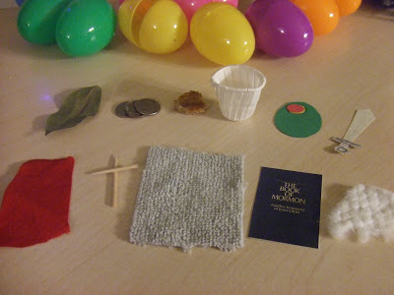](http://1.bp.blogspot.com/-kuUUJfeKrRI/T39QZOQXJVI/AAAAAAAABcM/xw2iIcW0KT0/s1600/DSCF4198.JPG) [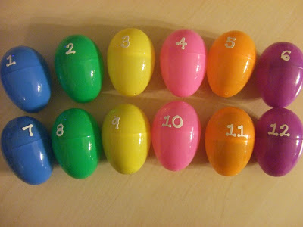](http://2.bp.blogspot.com/-MMZBEF38uaA/T39QdgXeRpI/AAAAAAAABcY/BP8ZMRot2F8/s1600/DSCF4201.JPG) [](http://1.bp.blogspot.com/-SvHg9MzH_Oo/T39QtOvTDnI/AAAAAAAABcw/m2UpI-cmUwM/s1600/DSCF4207.JPG)  
  
  
  
  
You can help your children better understand the true meaning of Easter by using this Easter Egg activity in class or giving them the materials to take home and do it as a Family Home Evening: <http://tinyurl.com/qc7a6fd>   
  
  
  
  
  
* Keep in mind that if your class members are 8-11 years old, that doing a FHE with their families passes off a Faith in God requirement. Encourage them to come back afterwards so you can sign it off in their books.

   
by Reyna Aburto  
Primary general board