

#### 

|  |  |  |  |
| --- | --- | --- | --- |
| **Nursery** | **Primary 1** | **Primary 2** | **Primary 4** |
|  |  |  |  |
|  |  |  |  |
|  |  |  |  |
|  |  |  |  |
|  |  |  |  |

# [**Use Cell Phones to Reach Nursery Parents**](http://www.themormonhome.com/super-simple-tip-use-cell-phones-to-reach-nursery-parents/) Microsoft Word - Nursery Cell Phone Sign up Sheet.docx Parents can leave their cell phones on vibrate in their pocket or purse, then when Nursery leaders need to find a parent for a diaper change or potty breaks, they can simply *TEXT* the parent to return to the Nursery room and take care of their child. For a copy of this printable, go here: [**http://tinyurl.com/nebox98**](http://tinyurl.com/nebox98)

"My Senior Primary Class spends more time looking up a scripture than reading it.  So, I made these bookmarks to hand out at the beginning of class. Then, while the kiddos are coming in, the others can be looking up their assignment.  I am laminating and using a washable dry erase marker to write in the scripture.  The students then give them back at the end of class and I can have ready for next lesson." (Shared by Rusty Willson)   
  
  
  
  
  
  
For a copy of his bookmarks go here: http://tinyurl.com/oqbok7a

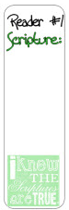



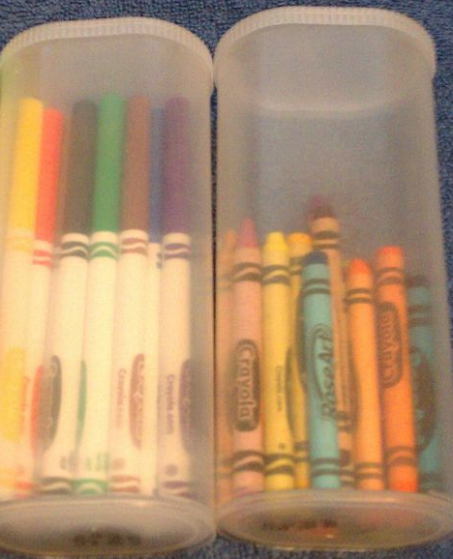  
  
Crystal Light containers are a great repurposed to organize some of your classroom staples.

### **Tip from Lisa Parent:** Between the first and second hours of Primary, I line the children up in the hall, and everyone gets a drink and goes to the bathroom. This makes it so no one has to leave during class or sharing time.

*Have extra time in class? Throughout the year, use some of these simple time fillers to teach and encourage your class to memorize the Articles of Faith.*



  
  
  
  
Work on memorizing the Articles of Faith as a class. Even small children can benefit from learning the Articles   
of Faith. However, if the children in your class are 8-11 years old, memorizing the Articles of Faith will help   
them fulfill part of their Faith in God requirements. You could hold a “13 Articles of Taste” Ice cream party for   
your class if they pass them all off in the year. Check out this party idea: [**http://tinyurl.com/ogqknpj**](http://tinyurl.com/ogqknpj)



[**http://tinyurl.com/nnhfmz3**](http://tinyurl.com/nnhfmz3)

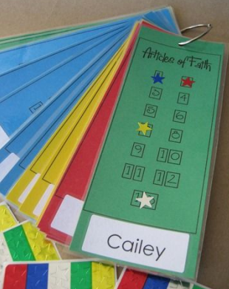  
  
**Article of Faith Tracking Cards**http://tinyurl.com/  
qcejxjn

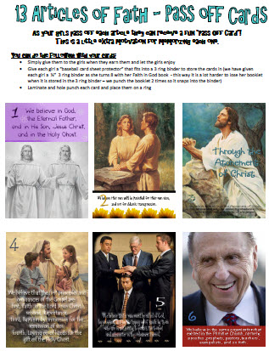  
**Article of Faith Pass Off Cards**  
<http://tinyurl.com/qyepymo>  
  
**MORE CARDS:** http://tinyurl.com/pzgtlqz

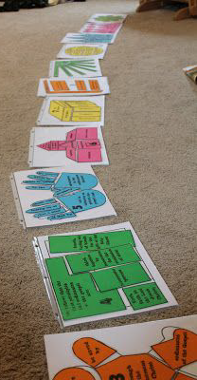  
  
  
  
  
  
  
**Article of Faith Puzzles:**  
<http://tinyurl.com/o4md5fu>

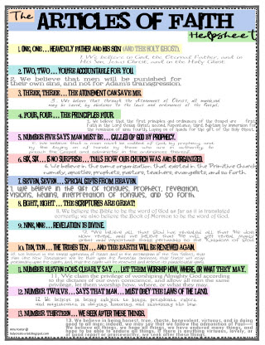  
http://tinyurl.com/nfgwz36

[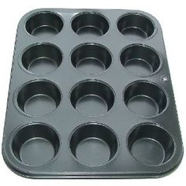](https://www.pinterest.com/recipes/deep-muffin-tray/)  
  
  
  
  
**REVIEW IDEA:**  Have the players stand back about eight feet and throw a bean bag into a muffin tin. The muffin tin has numbers in the bottom. The person has to say the Article of Faith corresponding to the number of the partition the bag lands in. If they don’t make any of the twelve tins, then they have to repeat the 13th AOF. Younger children can repeat the Articles of Faith with you. The older children can repeat them without your help.

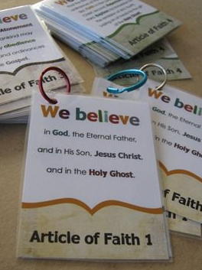  
  
<http://tinyurl.com/3hatq7b>