

#### 



|  |  |  |  |
| --- | --- | --- | --- |
| **Nursery** | **Primary 1** | **Primary 2** | **Primary 4** |
|  |  |  |  |
|  |  |  |  |
|  |  |  |  |
|  |  |  |  |
|  |  |  |  |

### **Thanksgiving Blessing Mix and printable** for your Primary class. Printable includes a tag (like the one pictured or a bag topper for a Ziploc bag) <http://tinyurl.com/h7zeczf>



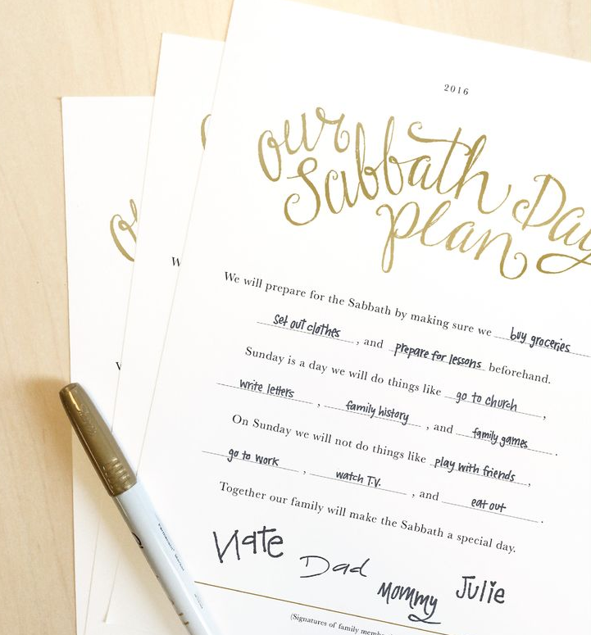  
  
Have extra time left over after class?   
  
Print up a copy of   
**“Our Sabbath Day Plan”**and help your class fill them out.   
  
<http://tinyurl.com/zf5tlwd>  
  
Discuss the importance of having a plan to keep the Sabbath Day special. Encourage them to discuss their plan with their families.

  
  
Church-produced lesson manuals are carefully prepared to ensure that the doctrines of the Church are kept pure. They establish guidelines for teaching in Church settings, and they ensure a consistent approach to gospel topics and principles. You should be true to the teachings and guidelines in these manuals. However, you do not need to present lessons exactly as they appear in the manuals. You may adapt the lessons according to the needs and circumstances of those you teach.

Whatever you do to adapt lessons, remember that your adaptations should help learners understand and live gospel principles. Therefore, adaptations should be made only after prayerful study of the lesson material and consideration of each individual you teach. As you seek to adapt a lesson, you should be guided by (1) the manual you have been given; (2) the following three questions: What should happen in the lives of those I teach as a result of this lesson? Which specific principles should be taught? How should these principles be taught?; and (3) the standards of teaching outlined in this book, such as loving those you teach, teaching by the Spirit, and teaching the doctrine.   
  
Examples of Lesson Adaptations - the following situations represent a few ways in which you might adapt lessons to those you teach.

**Using Material from Recent Church Magazines**

As you read a story in a lesson about service, you are reminded of a similar story in a recent Church magazine. You feel that the young women in your class will relate better to the story in the magazine, so you use that story instead of the one in the manual.

**Developing Your Own Learning Activities**

As you prepare a lesson for a group of Primary children, you read the attention activity at the beginning of the lesson. You feel that this particular activity might not help the children in your class. You ponder the needs of the children and develop an activity that will help them focus on the principles you are going to teach.

**Departing from the Suggested Lesson Development**

You are preparing to teach the deacons in your ward. The Aaronic Priesthood lesson manual suggests using a role play to help them apply a gospel principle. As you think about the young men you teach, you are reminded of some experiences they have had recently. You feel that a simple discussion about those experiences would be more effective than a role play.

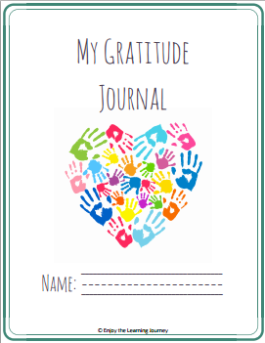 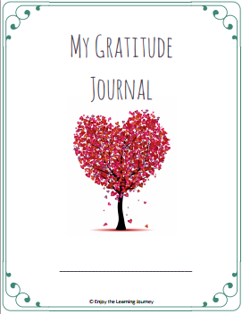

You could encourage your class to keep a gratitude journal during the month of November to remember their blessings. You could have them use a simple notebook or you can grab a free printable download here:  
  
http://tinyurl.com/h22sdv8