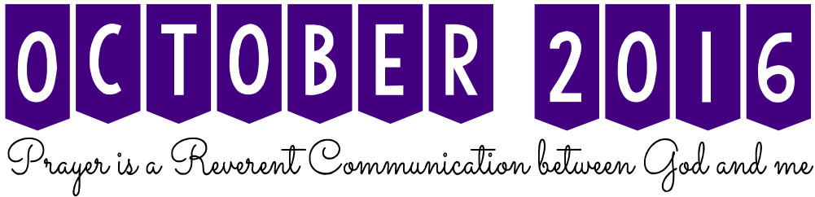

Like a conductor who brings musicians together at the beginning of a concert, you should bring class members together at the beginning of a lesson.

  
 Before you begin a lesson, some people may be reading, others may be sitting quietly, and others may be talking to one another. You may hear several conversations at the same time. Even after an opening prayer, those present may not be completely focused on contributing to the lesson. And although it takes more than lifting a baton, there are several simple ways to focus everyone’s attention on a lesson. As you teach different lessons, do not begin with the same method every time. Variety will add interest and an element of surprise. You can use objects to teach gospel principle. For example, to begin a lesson about choosing things that are of most worth to the soul, you could display a real piece of money next to a piece of play money or a plain piece of paper that is the same size as the money. Then ask those you teach which they would take as payment for the work they do. This could lead to a discussion about which teachings are genuine and which teachings are counterfeit.

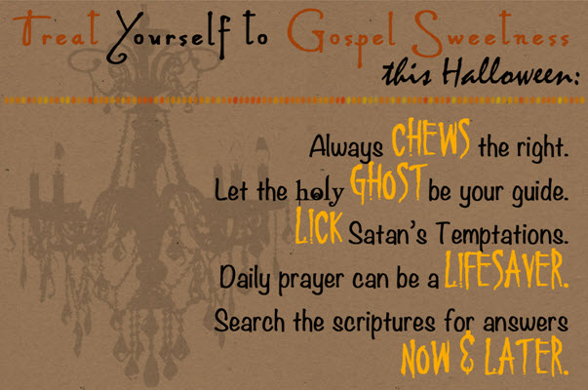 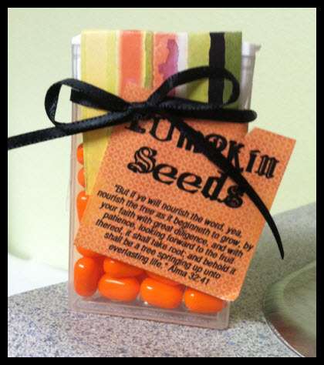



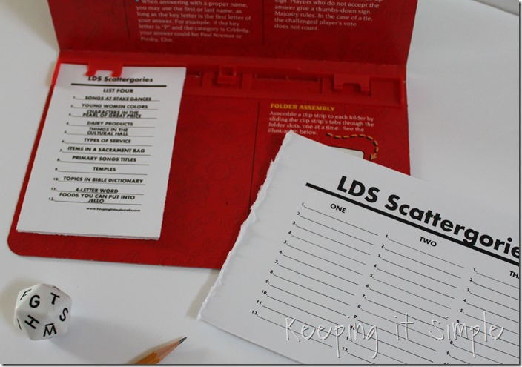  
  
GAME IDEA:   
  
**LDS Scattegories**  
<http://tinyurl.com/jefuysq>  
  
*You could make your own   
version and customize it to what   
you are learning in class (specifically the Book of Mormon)*

#### 

|  |  |  |  |
| --- | --- | --- | --- |
| **Nursery** | **Primary 1** | **Primary 2** | **Primary 4** |
|  |  |  |  |
|  |  |  |  |
|  |  |  |  |
|  |  |  |  |
|  |  |  |  |

Are things are getting stale? Do you want to bring more reverence into the classroom? Or do you just want to make a different impact? The easiest thing to do is change the way your classroom is set up. Try one of these 9 different ways and see what happens:

**TABLES** - If you are lucky, you have that small table in your classroom to put your things on. Instead of hogging the table to yourself, use it in a different way. Put it in the middle of the classroom and put objects on it. If you have a small class, you can all gather around it. With my larger class in Young Women's I bring in bigger tables. We love using a round table. It creates really good discussion as we all gather in a circle. The big rectangular table works well when I am doing lots of board work. We use notebooks a lot and its really helpful to have it in our classroom. My class is old enough to help me move it in and out which is nice. When I teach all the Young Women, I have done a couple of round tables. Its great if you are planning on group work too even in Relief Society. Bring in a few objects for display. When eyes start to wander at least there is something to look at that relates back to the lesson.

**CHAIRS** - Typically classrooms are set up in either rows or semicircles. Try changing it to a full circle or removing all the chairs and sit on the floor (bring a picnic blanket even). My seminary teacher would occasionally do this with a sign on the door asking for us to remove our shoes and be extra reverent. It always created a great atmosphere for our lessons specifically about Jesus Christ. What formation do you like the best? I personally hate it when I sit somewhere then asked to move to the front. I totally get the reason but I had a reason to sit where I did too. At least with the chairs moved, I can still sit somewhere I'm comfortable with but also makes the teacher happy.

**THE BOARD** - Everyone loves having something to look at on the board. The beauty of putting up a quote or scriptures on the board is people are already thinking about it before you even ask them. I love the building we have now where there are several white boards on sliders in the Relief Society room. It’s so nice to write on the board and hide it behind another until I need it- definitely saves time and makes the lesson go more smoothly because I'm not pausing to write. In Young Women's we just have the one white board so this last week I prepared papers ahead of time and just had them facing the board. The girls love picking them to unveil what's on the other side. If you are planning on using magnets- make sure they are strong ones. It’s so annoying to have pictures slide down the board during the lesson. Also, its super helpful for the students if you write down the scriptures you will be looking up during class on the board. I've been through several lessons that I had no idea where we were the entire time.

**MUSIC** - Trying to create a reverent atmosphere? Check out a CD player from the library or bring a device to play some church music. The church has great music players on their site now. If you can create a playlist of music that goes with your lesson ahead of time it’s even better. If you can bring a special musical guest that is even more fun.

**CLEAN UP** - Do a quick once over. It’s amazing what people pick up on when there eyes wander during a lesson. They will find that one piece of trash and may cause disturbances. If there is one hymn book in the classroom someone always ends up playing with it unless its put out of the way.

**TEMPERATURE** - This one is a tricky one especially with a room full of women. Some will think it’s too hot, others too cold, and of course, some are perfectly content. However, at least push the temporary occupied button- most of the time that will do the trick. If you need to open a window, remember people may have seasonal allergies and there will be unplanned loud noise since no one thinks to be quiet once they are outside the building.

**LIGHTS** - You don't always have to have them on. When it’s a sunny day, I sometimes leave them off. It creates a more relaxed atmosphere. Try bringing a lamp from home for a special lesson.

**DECORATIONS AROUND THE ROOM** - Don't go crazy mind you but can you put pictures around the room? If everyone is sitting in a circle maybe you can walk to the different pictures as you talk about different points of your lesson.

**WALK IN ACTIVITY** - As people walk in, have them involved in the lesson right away by doing an activity. One day I asked the Young Women to make a picture of something important in their bedrooms then hang it up on one of the boards in the room. Maybe they can do a journaling activity or quick quiz when they come in. Sometimes I have a handout for the Young Women to glue in their notebooks right away or a chart to make before we get going. Anything that helps set the tone. A little preparation can change the entire lesson. I love changing things up because it usually allows the mind to open a little bit more which allows for more discussion. It helps take us out of just going through the motions and actually learn again.   
  
***SOURCE:*** *http://www.cknscratch.com/teaching-tips-and-tricks/2014/9/6/ways-to-prepare-the-classroom*