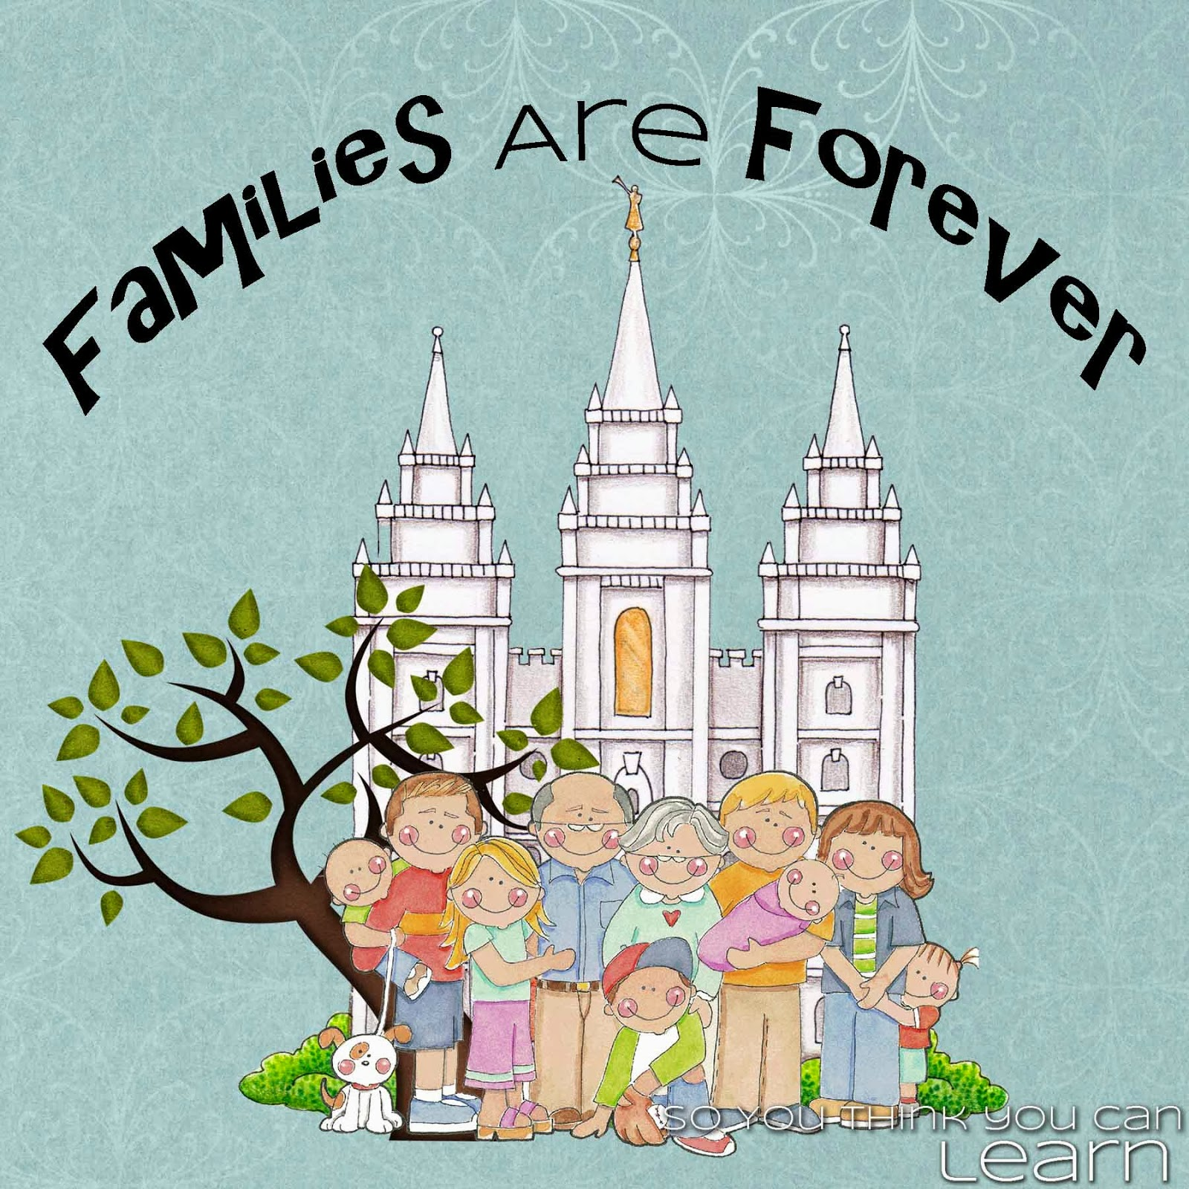

“Families Are Forever”

*“And he shall turn the heart of the fathers to the children,   
and the heart of the children to their fathers.”*

*~Malachi 4:6*

**2014 Calendar**

Image Source: http://tinyurl.com/nc73ouh

|  |  |  |  |  |  |  |
| --- | --- | --- | --- | --- | --- | --- |
| **Sunday**  January | **Monday** | **Tuesday** | **Wednesday** | **Thursday** | **Friday** | **Saturday** |
|  |  |  | 1  NEW YEARS DAY  C:\Documents and Settings\3407061115\Local Settings\Temporary Internet Files\Content.IE5\KX7VP81K\MC900304913[1].wmf | 2 | 3 | 4 |
| 5  FAST SUNDAY | 6 | 7 | 8 | 9 | 10 | 11 |
| 12 | 13 | 14 | 15 | 16 | 17 | 18 |
| 19 | 20  MARTIN LUTHER KING JR  DAY | 21 | 22 | 23 | 24 | 25 |
| 26 | 27 | 28 | 29 | 30 | 31 |  |

**Birthdays:**

**January Theme:** Heavenly Father Prepared a Way for Me to Return to His Presence

**January Scripture**: “For God so loved the world that he gave his only begotten Son, that whosoever believeth in him should not perish, but have everlasting life.” ~John 3:16

PRESIDENCY MEETING NOTES

PRESIDENCY MEETING NOTES

­­­

CONDUCTING:

SHARING TIME:

HALL MONITOR:

|  |  |  |  |  |  |  |
| --- | --- | --- | --- | --- | --- | --- |
| **Sunday**  February | **Monday** | **Tuesday** | **Wednesday** | **Thursday** | **Friday** | **Saturday** |
|  |  |  |  |  |  | 1 |
| 2 | 3 | 4 | 5 | 6 | 7 | 8 |
| 9 | 10 | 11 | 12 | 13 | 14  **VALENTINE’S**  **DAY**  **C:\Documents and Settings\3407061115\Local Settings\Temporary Internet Files\Content.IE5\82K4YYS7\MC900436243[1].png** | 15 |
| 16 | 17  **PRESIDENTS DAY**  **C:\Documents and Settings\3407061115\Local Settings\Temporary Internet Files\Content.IE5\KX7VP81K\MC900019782[1].wmf** | 18 | 19 | 20 | 21 | **22** |
| 23 | 24 | 25 | 26 | 27 | 28 |  |

**Birthdays:**

**February Theme:** Heavenly Father Has a Plan for His Children

**February Scripture:** “O how great the plan of God!” 2 Nephi 9:13

PRESIDENCY MEETING NOTES

­­­

PRESIDENCY MEETING NOTES

CONDUCTING:

SHARING TIME:

HALL MONITOR:

|  |  |  |  |  |  |  |
| --- | --- | --- | --- | --- | --- | --- |
| **Sunday**  March | **Monday** | **Tuesday** | **Wednesday** | **Thursday** | **Friday** | **Saturday** |
|  |  |  |  |  |  | 1 |
| 2  FAST SUNDAY | 3 | 4 | 5 | 6 | 7 | 8 |
| 9 | 10 | 11 | 12 | 13 | 14 | 15 |
| 16 | 17  **ST PATRICKS DAY**  **C:\Documents and Settings\3407061115\Local Settings\Temporary Internet Files\Content.IE5\MISVJY3O\MC900307559[1].wmf** | 18 | 19 | 20 | 21 | 22 |
| 23/30 | 24/31 | 25 | 26 | 27 | 28 | 29 |

**Birthdays:**

**March Theme:** Jesus Christ Is Our Savior

**March Scripture:** *“We have seen and do testify that the Father sent the Son to be the Saviour of the world.” 1 John 4:14*

PRESIDENCY MEETING NOTES

­­­

PRESIDENCY MEETING NOTES

CONDUCTING:

SHARING TIME:

HALL MONITOR:

|  |  |  |  |  |  |  |
| --- | --- | --- | --- | --- | --- | --- |
| **Sunday**  April | **Monday** | **Tuesday** | **Wednesday** | **Thursday** | **Friday** | **Saturday** |
|  |  | 1 | 2 | 3 | 4 | 5  GENERAL  CONFERENCE |
| **6**  GENERAL CONFERENCE | 7 | 8 | 9 | 10 | 11 | 12 |
| 13 | 14 | 15 | 16 | 17 | 18 | 19 |
| 20  **EASTER**  **SUNDAY**  **C:\Documents and Settings\3407061115\Local Settings\Temporary Internet Files\Content.IE5\KX7VP81K\MC900098093[1].wmf** | 21 | 22 | 23 | 24 | 25 | 26 |
| 27 | 28 | 29 | 30 |  |  |  |

**Birthdays:**

“Growing and Maturing in Self-R

**April Theme:** The Family Is Central to God’s Plan

**April Scripture:** “Marriage between a man and a woman is ordained of God and…the family is central to the Creator’s plan for the eternal destiny of His children.” The Family: A Proclamation to the World

PRESIDENCY MEETING NOTES

­­­

PRESIDENCY MEETING NOTES

CONDUCTING:

SHARING TIME:

HALL MONITOR:

|  |  |  |  |  |  |  |
| --- | --- | --- | --- | --- | --- | --- |
| **Sunday**  May | **Monday** | **Tuesday** | **Wednesday** | **Thursday** | **Friday** | **Saturday** |
|  |  |  |  | 1 | 2 | 3 |
| 4  FAST SUNDAY | 5 | 6 | 7 | 8 | 9 | 10 |
| 11  **MOTHER’S**  **DAY**  **C:\Documents and Settings\3407061115\Local Settings\Temporary Internet Files\Content.IE5\KX7VP81K\MC900326844[1].wmf** | 12 | 13 | 14 | 15 | 16 | 17 |
| 18 | 19 | 20 | 21 | 22 | 23 | 24 |
| 25 | 26  **MEMORIAL**  **DAY**  **C:\Documents and Settings\3407061115\Local Settings\Temporary Internet Files\Content.IE5\82K4YYS7\MC900149615[1].wmf** | 27 | 28 | 29 | 30 | 31 |

**Birthdays:**

**May Theme:** Families Are Blessed When They Follow the Prophet

**May Scripture:** “Be mindful of the words which were spoken before by the holy prophets.”

2 Peter 3:2

PRESIDENCY MEETING NOTES

­­­

PRESIDENCY MEETING NOTES

CONDUCTING:

SHARING TIME:

HALL MONITOR:

|  |  |  |  |  |  |  |
| --- | --- | --- | --- | --- | --- | --- |
| **Sunday**  June | **Monday** | **Tuesday** | **Wednesday** | **Thursday** | **Friday** | **Saturday** |
| 1  FAST SUNDAY | 2 | 3 | 4 | 5 | 6 | 7 |
| 8 | 9 | 10 | 11 | 12 | 13 | 14  **FLAG**  **C:\Documents and Settings\3407061115\Local Settings\Temporary Internet Files\Content.IE5\QSKXP1UL\MC900436375[1].pngDAY** |
| 15  **FATHER’S  DAY**  **C:\Documents and Settings\3407061115\Local Settings\Temporary Internet Files\Content.IE5\GUE6AKUJ\MC900023373[1].wmf** | 16 | 17 | 18 | 19 | 20 | 21 |
| 22 | 23 | 24 | 25 | 26 | 27 | 28 |
| 29 | 30 |  |  |  |  |  |

**Birthdays:**

**June Theme**: Priesthood Ordinances and Temple Work Bless My Family

**June Scripture:** “Whatsoever ye shall bind on earth shall be bound in heaven.” Matthew 18:18

PRESIDENCY MEETING NOTES

­­­

PRESIDENCY MEETING NOTES

CONDUCTING:

SHARING TIME:

HALL MONITOR:

|  |  |  |  |  |  |  |
| --- | --- | --- | --- | --- | --- | --- |
| **Sunday**  July | **Monday** | **Tuesday** | **Wednesday** | **Thursday** | **Friday** | **Saturday** |
|  |  | 1 | 2 | 3 | 4  **INDEPENDENCE DAY**  **C:\Documents and Settings\3407061115\Local Settings\Temporary Internet Files\Content.IE5\09XP3PJU\MC900287390[1].wmf** | 5 |
| 6  FAST SUNDAY | 7 | 8 | 9 | 10 | 11 | 12 |
| 13 | 14 | 15 | 16 | 17 | 18 | 19 |
| 20 | 21 | 22 | 23 | 24  **PIONEER DAY**  **C:\Documents and Settings\3407061115\Local Settings\Temporary Internet Files\Content.IE5\MISVJY3O\MC900151183[1].wmf** | 25 | 26 |
| 27 | 28 | 29 | 30 | 31 |  |  |

**Birthdays:**

**July Theme:** We Become Members of the Church through Baptism and Confirmation

**July Scripture:** “Except a man be bron of water and of the Spirit, he cannot enter into the kingdom of God.” John 3:5

PRESIDENCY MEETING NOTES

­­

PRESIDENCY MEETING NOTES

CONDUCTING:

SHARING TIME:

HALL MONITOR:

|  |  |  |  |  |  |  |
| --- | --- | --- | --- | --- | --- | --- |
| **Sunday**  August | **Monday** | **Tuesday** | **Wednesday** | **Thursday** | **Friday** | **Saturday** |
|  |  |  |  |  | 1 | 2 |
| 3  FAST SUNDAY | 4 | 5 | 6 | 7 | 8 | 9 |
| 10 | 11 | 12 | 13 | 14 | 15 | 16 |
| 17 | 18 | 19 | 20 | 21 | 22 | 23 |
| 24/31 | 25 | 26 | 27 | 28 | 29 | 30 |

**Birthdays:**

**August Theme**: Participating in Wholesome Activities Will Strengthen My Family

**August Scripture**:”Successful…families are established and maintained on principles of faith, prayer, repentance, forgiveness, respect, love, compassion, work, and wholesome recreational activities.” The Family: A Proclamation to the World

PRESIDENCY MEETING NOTES

­­­

PRESIDENCY MEETING NOTES

CONDUCTING:

SHARING TIME:

HALL MONITOR:

|  |  |  |  |  |  |  |
| --- | --- | --- | --- | --- | --- | --- |
| **Sunday**  September | **Monday** | **Tuesday** | **Wednesday** | **Thursday** | **Friday** | **Saturday** |
|  | 1  **LABOR**  **DAY** | 2 | 3 | 4 | 5 | 6 |
| 7  FAST SUNDAY | 8 | 9 | 10 | 11  **PATRIOT DAY**  **(9/11-Never Forget)** | 12 | 13 |
| 14 | 15 | 16 | 17 | 18 | 19 | 20 |
| 21 | 22 | 23 | 24 | 25 | 26 | 27 |
| 28 | 29 | 30 |  |  |  |  |

**Birthdays:**

**September Theme:** Living the Gospel Blesses My Family

**September Scripture:** “We believe in being honest, true, chaste, benevolent, virtuous, and in doing good to all men; indeed, we may say that we follow the admonition of Paul-We believe all things, we hope all things, we have endured many things, and hope to endure all things. If there is anything virtuous, lovely, or of good report or praiseworthy, we seek after these things.” Article of Faith 1:13

PRESIDENCY MEETING NOTES

­­­

PRESIDENCY MEETING NOTES

CONDUCTING:

SHARING TIME:

HALL MONITOR:

|  |  |  |  |  |  |  |
| --- | --- | --- | --- | --- | --- | --- |
| **Sunday**  October | **Monday** | **Tuesday** | **Wednesday** | **Thursday** | **Friday** | **Saturday** |
|  |  |  | 1 | 2 | 3 | 4  GENERAL CONFERENCE |
| 5  GENERAL CONFERENCE | 6 | 7 | 8 | 9 | 10 | 11 |
| 12 | 13 | 14 | 15 | 16 | 17 | 18 |
| 19 | 20 | 21 | 22 | 23 | 24 | 25 |
| 26 | 27 | 28 | 29 | 30 | 31  **HALLOWEEN**  **C:\Program Files\Microsoft Office\MEDIA\CAGCAT10\j0305493.wmf** |  |

**Birthdays:**

**October Theme**: “The Family: A Proclamation to the World” Came from God to Help My Family

**October Scripture:** “These things have I spoken unto you, that my job might remain in you, and that your job might be full.” John 15:11

PRESIDENCY MEETING NOTES

­­­

PRESIDENCY MEETING NOTES

CONDUCTING:

SHARING TIME:

HALL MONITOR:

|  |  |  |  |  |  |  |
| --- | --- | --- | --- | --- | --- | --- |
| **Sunday**  November | **Monday** | **Tuesday** | **Wednesday** | **Thursday** | **Friday** | **Saturday** |
|  |  |  |  |  |  | 1 |
| 2  FAST SUNDAY | 3 | 4 | 5 | 6 | 7 | 8 |
| 9 | 10 | 11 | 12 | 13 | 14 | 15 |
| 16 | 17 | 18 | 19 | 20 | 21 | 22 |
| 23/30 | 24 | 25 | 26 | 27  **THANKSGIVING**  **DAY**  **C:\Documents and Settings\3407061115\Local Settings\Temporary Internet Files\Content.IE5\Y858TYGJ\MC900151717[1].wmf** | 28 | 29 |

**Birthdays:**

**November Theme:** Living the Teachings of Jesus Christ Strengthens Me and My Family

**November Scripture:** “Happiness in family life is most likely to be achieved when founded upon the teachings of the Lord Jesus Christ.” The Family: A Proclamation to the World.

PRESIDENCY MEETING NOTES

­­­

PRESIDENCY MEETING NOTES

CONDUCTING:

SHARING TIME:

HALL MONITOR:

|  |  |  |  |  |  |  |
| --- | --- | --- | --- | --- | --- | --- |
| **Sunday**  December | **Monday** | **Tuesday** | **Wednesday** | **Thursday** | **Friday** | **Saturday** |
|  | 1 | 2 | 3 | 4 | 5 | 6 |
| 7  FAST SUNDAY | 8 | 9 | 10 | 11 | 12 | 13 |
| 14 | 15 | 16 | 17 | 18 | 19 | 20 |
| 21 | 22 | 23 | 24  **CHRISTMAS**  **EVE** | 25  **CHRISTMAS**  **DAY**  **C:\Documents and Settings\3407061115\Local Settings\Temporary Internet Files\Content.IE5\GUE6AKUJ\MC900363562[1].wmf** | 26 | 27 |
| 28 | 29 | 30 | 31  **NEW YEARS  EVE** |  |  |  |

**Birthdays:**

**December Theme:** We Remember and Worship Our Savior, Jesus Christ

**December Scripture**: “Jesus saith unto him, I am the way, the truth, and the life: no man commeth unto the father, but by me.” John 14:6

PRESIDENCY MEETING NOTES

­­­

PRESIDENCY MEETING NOTES

CONDUCTING:

SHARING TIME:

HALL MONITOR: