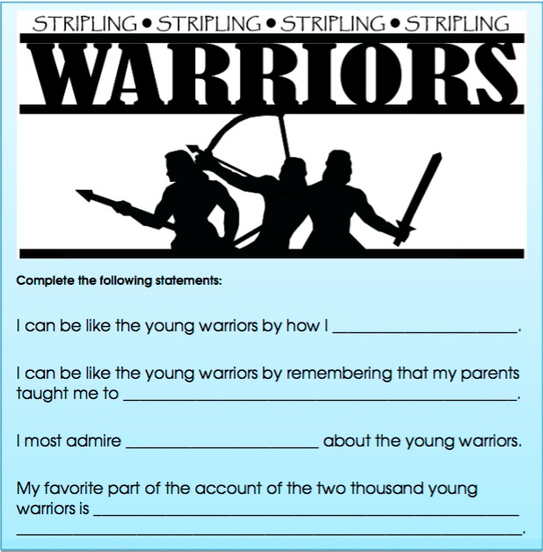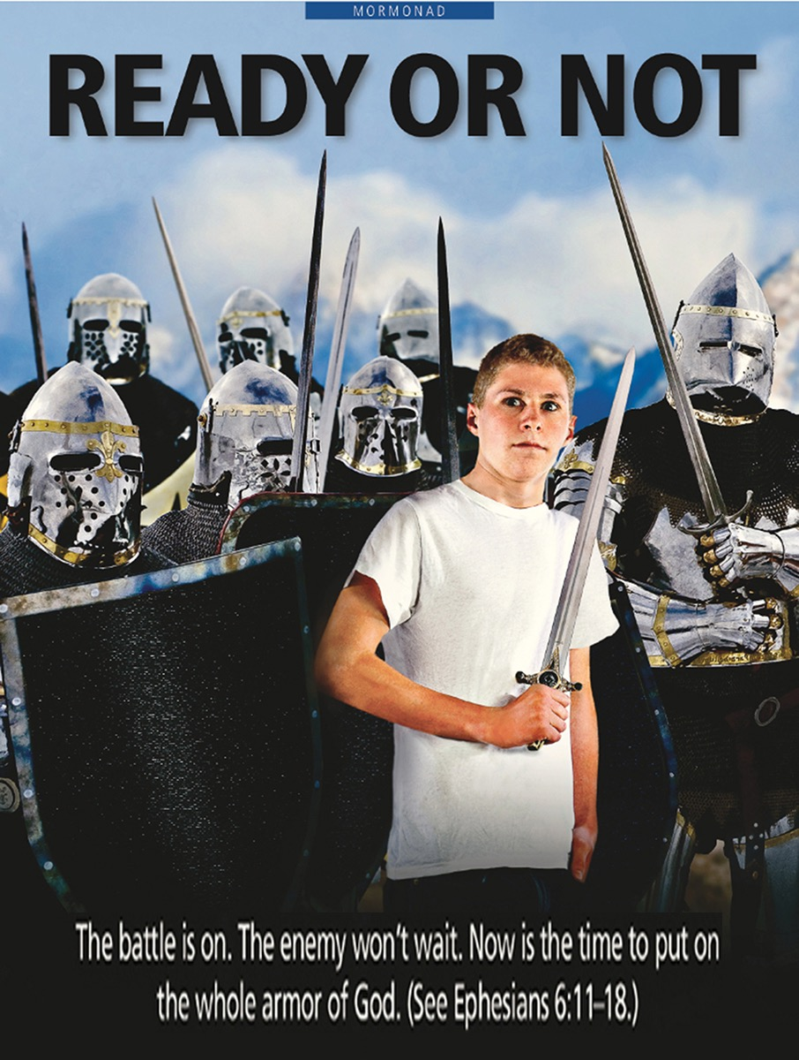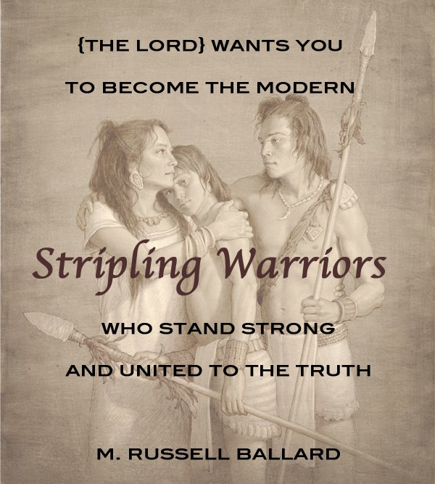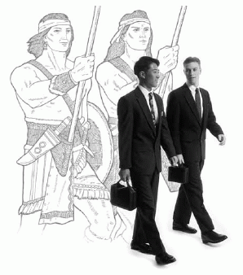



Valiant Newsletter

Book of

Mormon

My Goal: To teach me that following the examples and teachings of righteous parents gives us power to defend truth and right.

**HELAMAN AND THE TWO THOUSAND WARRIORS**

**——**

**Primary 4**

**Lesson: 27**

Study & Discuss

(with your family) [Alma 53:16–21](https://www.lds.org/scriptures/bofm/alma/53.16-21?lang=eng#15), [56:45–48](https://www.lds.org/scriptures/bofm/alma/56.45-48?lang=eng#44), and [Alma 57:25–27](https://www.lds.org/scriptures/bofm/alma/57.25-27?lang=eng#24)

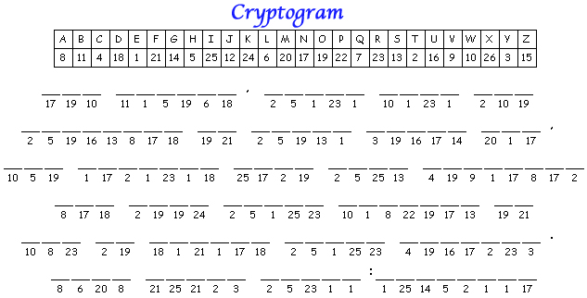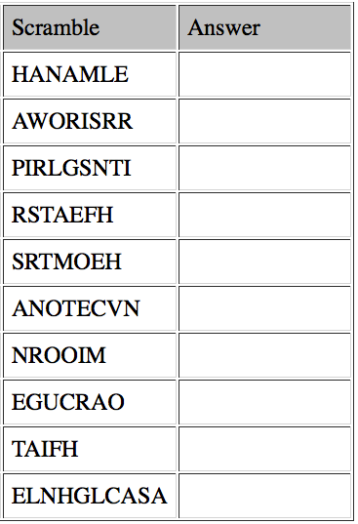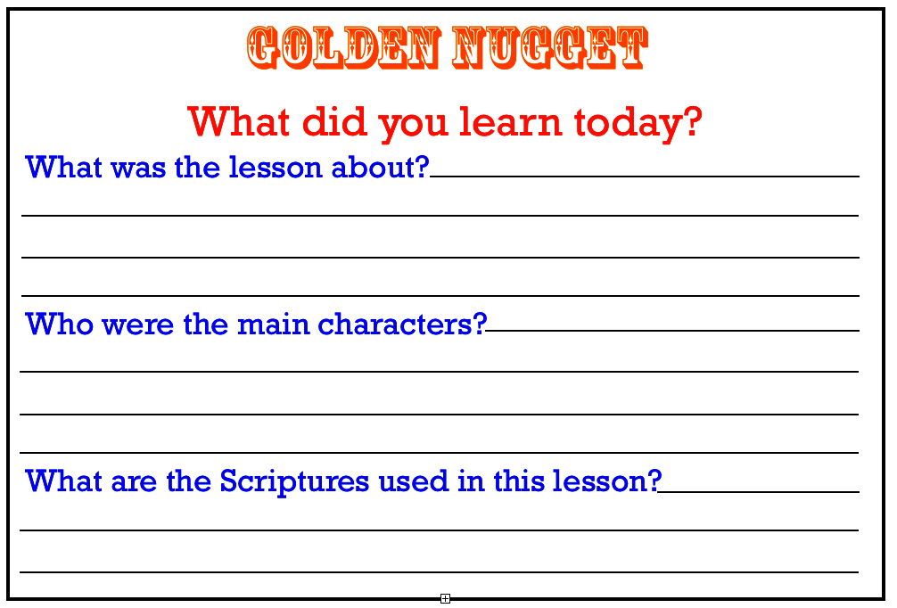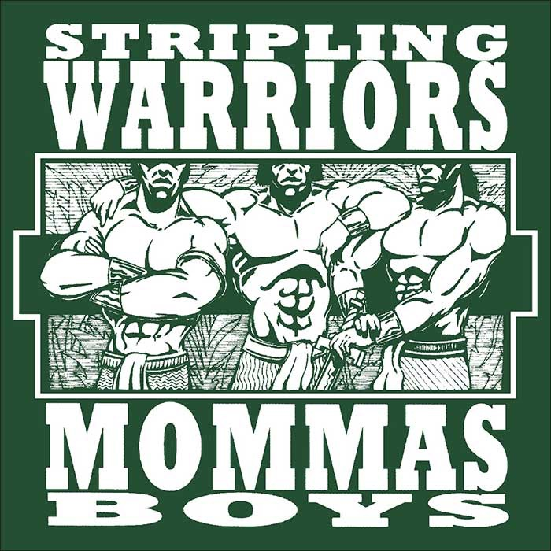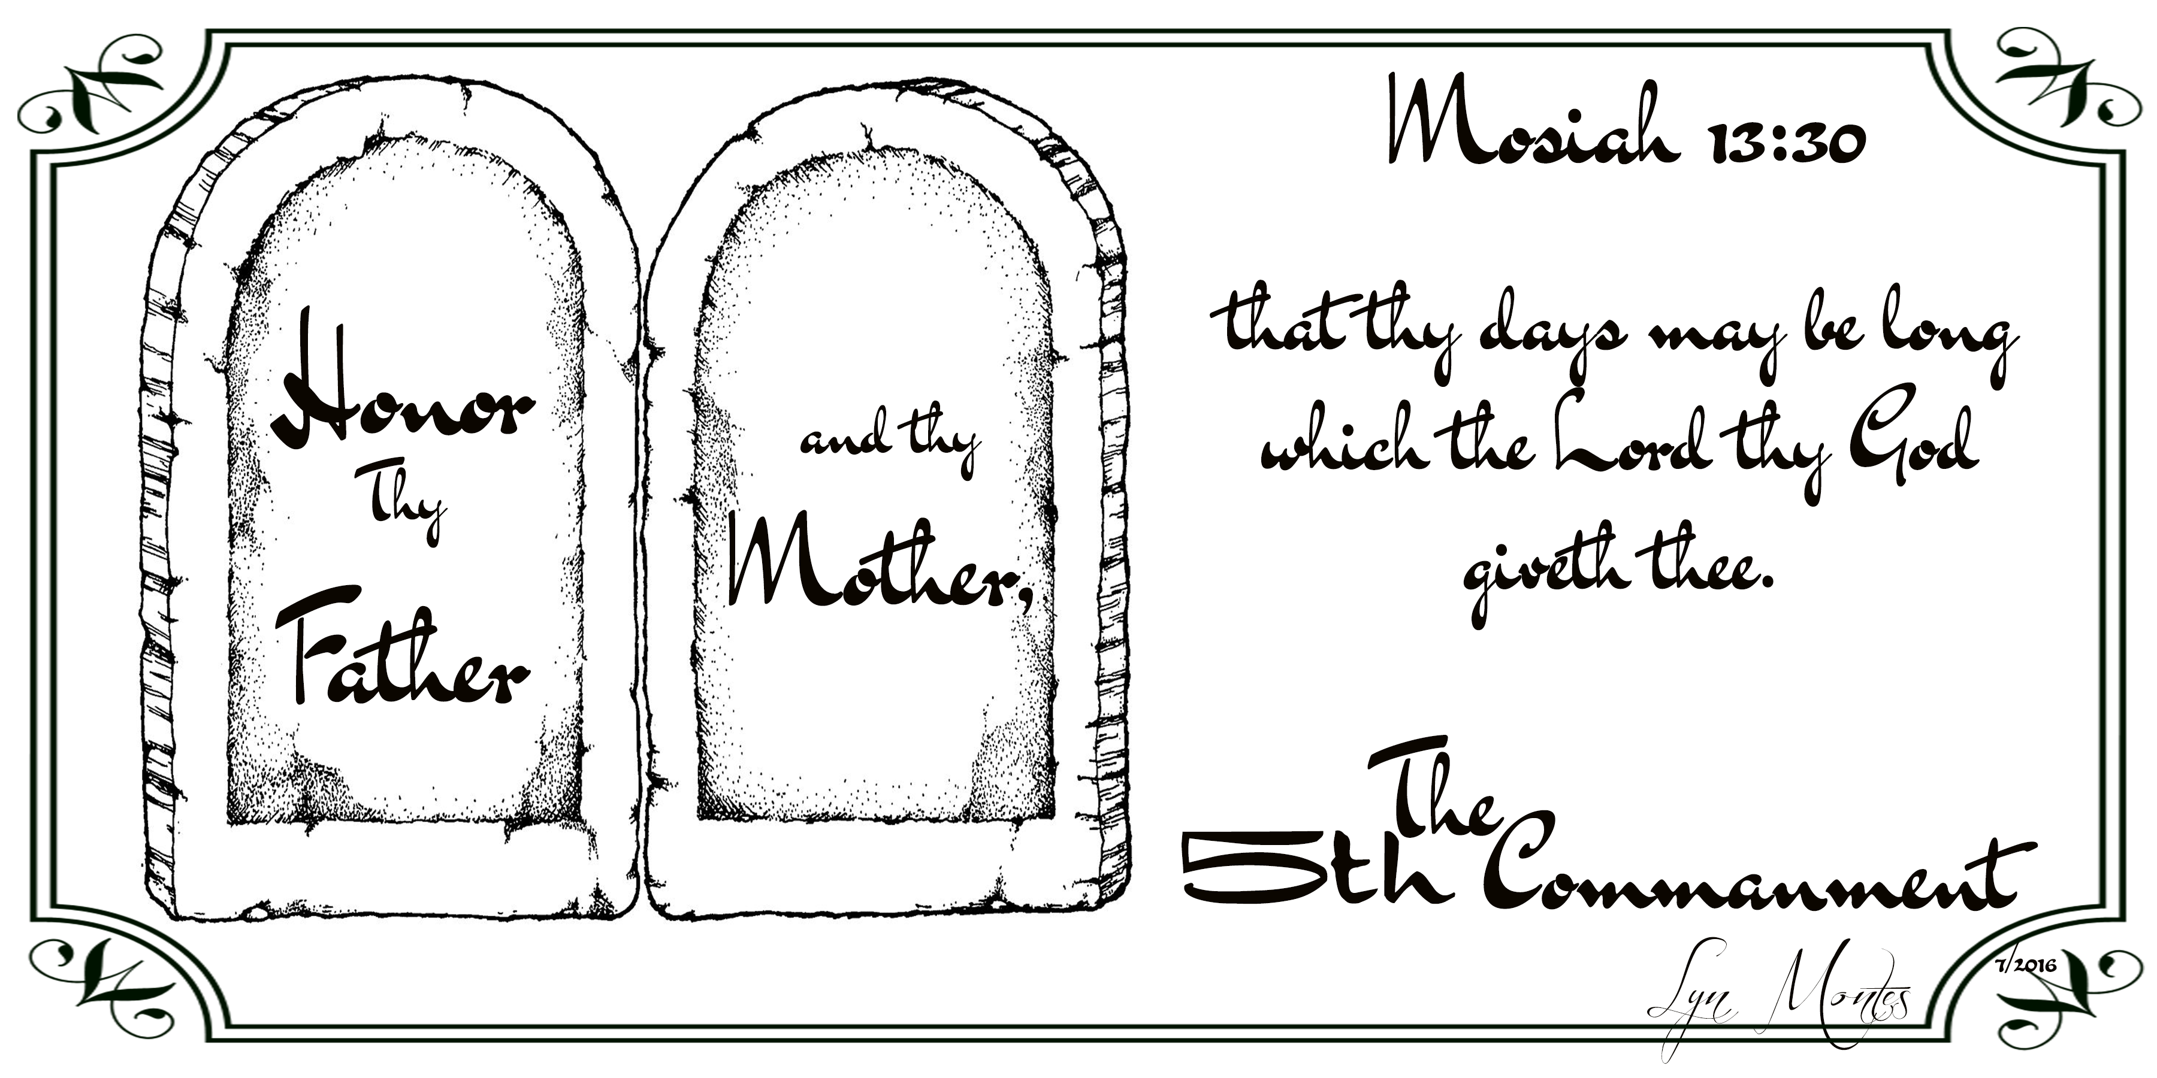

by Rudy and Lyn Montes ©



BATTLE COURAGEOUS DEFEND EXACTNESS

FAITH FOLLOW HELAMAN LIBERTY LISTENED LOVE MOTHERS OBEDIENT OBSERVE PARENTS RELIABLE RIGHT RIGHTEOUS STRENGTH STRIPLING TEACHINGS TRUSTWORTHY TRUTH

VALIANT WARRIOR YOUTH