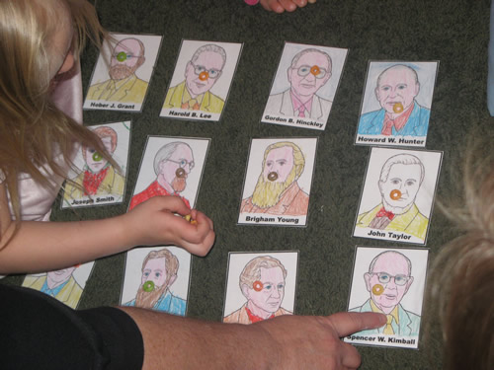

 ***A time filler for extra class time…*** Print off cards of each of the prophets (as seen in this picture) from here: <http://tinyurl.com/26u3qvr>.  Then you put a piece of cereal on each card.  Then you choose one person to go the other side of the room and face the wall.  The rest of the group decides on one of the prophets (by pointing since you don’t want them to hear you). For example say you chose Spencer W. Kimball.  Then, everyone starts singing, "Follow the Prophet" or "Later-Day Prophets".  The person you chose comes back to the group and starts taking the cereal piece off prophet card at a time.  Once they take the cereal off the designated prophet card (Spencer W. Kimball in this case), everyone stops singing and says in unison, "Don't eat the prophet!"  Then, you choose a new person and it all starts over again.

### “Every gospel teacher who seeks to follow the Master will focus all of his efforts on others and never on himself. Satan said, ‘Send me, … I will redeem all mankind, … and surely I will do it; wherefore give me thine honor.’ Contrast that proposal with the example of the Savior, who said, ‘Father, thy will be done, and the glory be thine forever’ ([Moses 4:1–2](https://www.lds.org/scriptures/pgp/moses/4.1-2?lang=eng#0)). A gospel teacher will focus his teaching on the needs of the sheep and the glory of the Master. He will avoid the limelight. He will teach the flock that they should always look to the Master. He will never obscure their view of the Master by standing in the way or by casting a shadow of self-promotion or self-interest.” - Elder Dallin H. Oaks, address given on March 31, 1998.

  
Need a handout to encourage your Primary class to watch General Conference? Here are a few ideas: <http://tinyurl.com/qxmjtds>

*“Every calling provides an opportunity to serve and to grow. The Lord organized the Church in a way that offers each member an opportunity for service, which, in turn, leads to personal spiritual growth. Whatever your calling, I urge you to see it as an opportunity not only to strengthen and bless others but also to become what Heavenly Father wants you to become.”   
 -- President Dieter F. Uchtdorf*

#### 

|  |  |  |  |
| --- | --- | --- | --- |
| **Nursery** | **Primary 1** | **Primary 2** | **Primary 4** |
|  |  |  |  |
|  |  |  |  |
|  |  |  |  |
|  |  |  |  |
|  |  |  |  |



#### **(VIDEO) Seeking the Spirit and Being Flexible -** By seeking the Spirit and by being flexible, this teacher was able to meet the children's need and teach them. (5:42) To watch this video go to: http://tinyurl.com/gsjfjhj

  
   
  
  
  
  
  
  
  
  
  
  


  
  
When we are filled with Christlike love for those we teach, our love is reflected in our preparation, our teaching, and our everyday lives. Think specifically of the children whom you teach and consider the following question: What are some things you can do to show Christlike love for these people? (Note that some ideas are listed in the following chart.) Feel free to add your own…..

|  |  |  |
| --- | --- | --- |
| **Preparation** | **Teaching** | **Everyday Life** |
| Pray for them. | Greet them warmly at the beginning of class. | Pray for them. |
| Be aware of their needs and interests. | Express your love for them. | Be friendly when you see them. |
| Be well prepared to teach them. | Listen attentively. | Be aware of their activities and accomplishments. |
|  | Respond respectfully as they participate in class. | Attend activities in which they are participating. |
|  | Encourage them to live the principles you teach. | Compliment them when appropriate. |
|  | Compliment them when appropriate. | Show concern and give encouragement when they experience trials. |