I will stand up
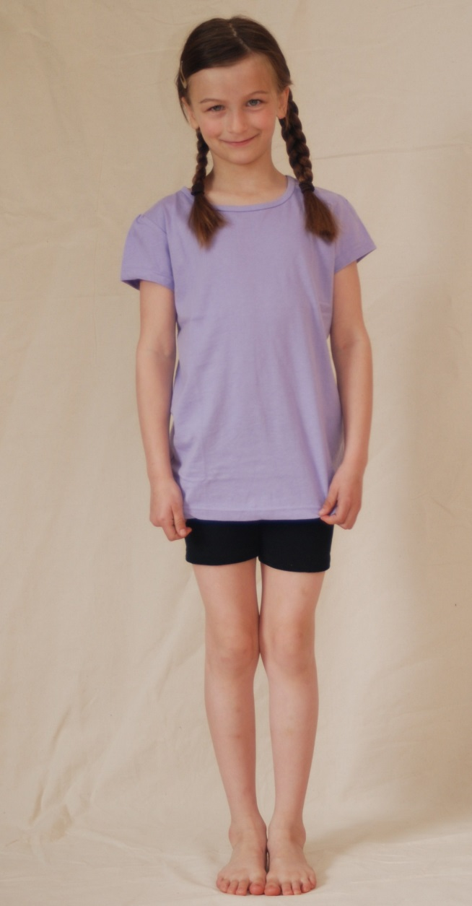
When “stand up’ is said,
Place my hands on top of my head,

Bend down low and touch the floor,
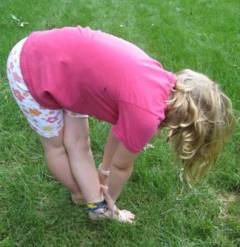
Shake my hands
(one, two, three, four),
Hands on hips
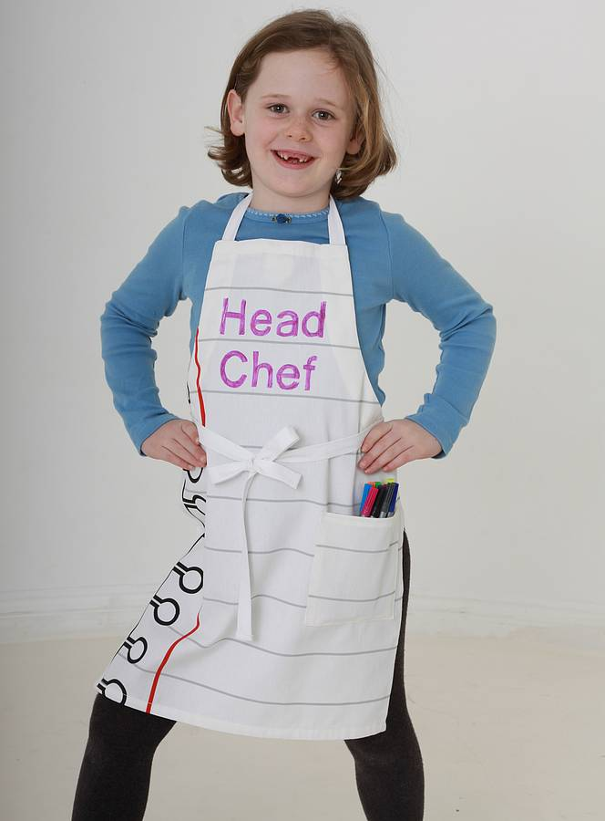
and turn around,
Give a smile,
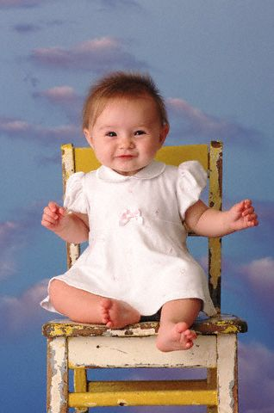
And then sit down.

Song: “Stand Up”
Children’s Songbook pg. 278

Words: Glenna Tate Holbrook
Music: Marjorie Castleton Kjar

Improvise actions as suggested by the words

