The Three Witnesses In Court
(fictional court based on the retelling of actual events—details taken from LDS Church History video “The Three Witnesses.”)

Judge – Order in the court, order in the court…. Ladies and gentlemen, you will be our jury as we put on trial these three men who have testified and written it here in this BofM that they have seen and angel who showed them golden plates.
Mr. Whitmer, you are one of 3 men who stated this and also that JS translated these plates into the Book of Mormon. Yet you no longer affiliate with the Mormon Church. Is that true Mr Whitmer?
DW – True your honor.
Judge – Then why did you feel a need to recently publish a letter in our local newspaper in which you stated of your testimony in the preface to the Book of Mormon that it was “no delusion” and “what is written is written.”?
DW – My integrity was under question sir. An acquaintance stated that I had denied my experience and I needed to set the record straight to all that hear.
Judge -- and how did you do this?
DW – I requested 22 men from the community, of the best reputation, to sign an affidavit stating that I am an honest man of the greatest integrity. I published it in the paper along with my letter stating to all that I do not deny my experience regardless of my standing with the Mormon Church.
Judge—And all these honorable men did sign your affidavit/
DW: That they did.
Judge: Now that JS is dead some 40 years do you still feel as strongly as you once did about JS and the BofM? Do you still say that J.S. is a prophet of God and that he translated the Word of God?
DW – Yes your honor, I do not deny it nor never will I.
Judge -- How did you come to be affiliated with JS?
DW – This man here, Oliver Cowdery, who was and remains my friend, introduced me to JS. I knew at once that his work was important and offered JS shelter until his translation of these plates were finished.
Judge – Mr. Cowdery, you also wrote that you were a witness to the Golden Plates. How did you become affiliated with JS.
OC – Sir, initially I became associated with the Smith family when they summoned me to tutor their children. I was fascinated when I heard about JS’s experiences and became a devoted follower and I served as JS’s scribe during the translation.
Judge – So you saw these plates as he translated them?
OC – No sir.
Judge -- No? Yet you say you were a witness, how can that be?
OC -- JS was not allowed to show the plates to anyone and once the work was completed he delivered the plates back to the angel, Moroni, without showing them to anyone.
Judge – So you admit that you did not see them?
OC – No sir. I said that I did not see them while I served as a scribe.
Judge – Then how did you become able to see them?
OC -- We were all curious and JS assured us that the Lord would choose witnesses. Although we found it unusual that he returned the plates, we had faith that witnesses would be called. Soon he told me I would be a witness along with Mr. Whitmer and Mr. Harris.
Judge – Mr. Harris, how did you become affilitated with JS?
MH -- I was a prosperous farmer near the Smith’s and I began to be associated with them and the church. Eventually, I used personal funds to help finance the publishing of the BofM.
Judge – Mr. Harris you were also a witness?
MHarris – Yes your Honor. JS told me that if I would humble myself, I would be a witness.
Judge – So you were with Mr. Cowdery and Mr. Whitmer when the supposed Angel appeared?
MH – No sir.
Judge -- Why not?
MH – We joined together in preparation to become witnesses. We went with JS to a private location to pray. JS prayed first and then each of us.
Judge – Then the angel appeared?
MH –No, so we repeated the pattern and again no result. Finally, as I prayed, I felt that it was because of me and certain issues I had that the angel was not able to appear and so I left their Company.
Judge – Mr. Whitmer is this true?
DW – Yes sir, and shortly thereafter, an angel appeared to us and showed the Golden Plates to myself and Oliver.
Judge -- So you admit, that Mr. Harris’ testimony is fraudulent?
DW – No sir, later that day. Mr Harris had sufficiently prepared himself and was also able to have the exact same experience as us and, therefore, also able to sign his name to the statement.
Judge: But you left the church that you were a witness for? Certainly, you no longer can support your statement.
DW: My leaving the church does not change the truth. I witnessed the gold plates.
Judge: I must admit, a court cannot receive any better evidence than three witnesses. Each of you, continue to stand as a witness even though each of you at one time or the other became disassociated with JS and the Mormon religion. A court can substantiate a claim with one solid witness but here we have three.
MH – Although I separated from the church and stayed in Kirtland, I later rejoined myself with the church in Utah and was rebaptized. I can tell you that I will never deny my testimony even on my deathbed. “..as assuredly as I see the sun and see you, I saw the Angel, the BofM is true, I saw what I saw and heard what I heard..” and I will never deny it.
Judge –Mr. Cowdery, after you left the church you became an attorney. Does your witness of this Book of Mormon in anyway weaken your credibility of presenting the truth in court?
OC –May I see that copy of the BofM? [read]“…the voice of the Lord commanded us that we should bear record of it; wherefore, to be obedient unto the commandments of God, we bear testimony of these things. And we know that if we are faithful in Christ, we shall rid our garments of the blood of all men, and be found spotless before the judgment-seat of Christ, and shall dwell with him eternally in the heavens. And the honor be to the Father, and to the Son, and to the Holy Ghost, which is one God. Amen.” It is literally true what I said that I saw and I know what I saw.
Judge – But you are no longer a member of this church?
OC – Correct, I left the church, but now 10 years later I am preparing to rejoin with the Mormon’s in Council Bluffs before they leave West. “I seek no station among my fellow Mormons but only desire to be identified with them. I was the first man to be baptized by the priesthood authority in this dispensation. I recorded the BofM as JS translated. I beheld the plates and the angel. I have never denied that JS is a prophet, true to his calling. Though I have been judged and persecuted by men, I will not deny my witness now or never.
Judge – Gentlemen, the said JS has been dead for over 40 years now and yet the three of you feel of him as strongly as you did when he was among you and all of you feel as strongly about the BofM and experience as a witness to the said plates. So much so, that you almost persuade me to be a Mormon. Court adjourned.

BACKGROUND INFORMATION:

The Experience of the Three Witnesses

D&C 17
Larry E. Morris26 December 2012
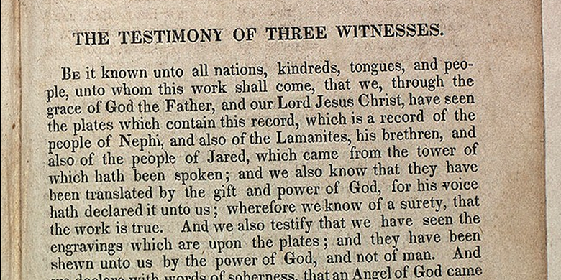
Testimony of Three Witnesses (1830 Book of Mormon)
More than five decades after the event, David Whitmer recalled how he first heard of the Book of Mormon: “I made a business trip to Palmyra, N. Y. [in 1828], and while there stopped with one Oliver Cowdery. A great many people in the neighborhood were talking about the finding of certain golden plates by one Joseph Smith, jr., a young man of that neighborhood. Cowdery and I, as well as others, talked about the matter.” The exact details of how 23-year-old Whitmer and 22-year-old Cowdery met are unknown, but they quickly struck up a friendship.
“Cowdery said he was acquainted with the Smith family,” Whitmer continued, “and he believed there must be some truth in the story of the plates, and that he intended to investigate the matter.” Whitmer, who implies that he made more than one trip to Palmyra, conducted his own investigation and “had conversations with several young men who said that Joseph Smith had certainly golden plates. ... These parties were so positive in their statements that I began to believe there must be some foundation for the stories then in circulation.”1
Whitmer, a farmer from Fayette Township, New York (about thirty miles southeast of Palmyra), and Cowdery, a Vermont native who had recently been hired by Hyrum Smith and other school trustees to teach in the Manchester district, agreed to keep each other informed of what they discovered. At this time, neither of them had met Joseph Smith, then living in Harmony, Pennsylvania, with his wife, Emma.
Cowdery, whose students included children of Joseph Sr. and Lucy Mack Smith, eventually boarded with that family. Lucy wrote that Cowdery “soon began to importune Mr. Smith on the subject [of the plates], but for a considerable time did not succeed in eliciting any information. At last, however, he gained my husband’s confidence, so far as to obtain a sketch of the facts relative to the plates.”
The conversation with Joseph Sr. had a powerful effect on Cowdery. “The subject ... seems working in my very bones,” he told the Smiths. “I have made it a subject of prayer, and I firmly believe that it is the will of the Lord that I should go [to Harmony to assist Joseph with the translation].”2
Cowdery also announced this news (apparently in a letter) to Whitmer. “Cowdery told me he was going to Harmony, Pa. ... and see him [Joseph Smith] about the matter,” Whitmer wrote. “He did go, and on his way stopped at my father’s house and told me that as soon as he found out anything either truth or untruth he would let me know.”
Joseph Smith and Oliver Cowdery began their translation project on April 7, 1829, and worked intensely over the next eight weeks. During that time, Cowdery wrote three letters to Whitmer, discussing the translation process and offering particular information on the content of the Book of Mormon. “When Cowdery wrote me these things and told me that he had revealed knowledge concerning the truth of them, I showed these letters to my parents, and brothers and sisters,” Whitmer recalled.3
In his last letter, Cowdery requested that Whitmer come to Harmony and help the two men move to the Whitmer home. “I had some 20 acres to plow,” Whitmer wrote, “so I concluded I would finish plowing and then go.” When he got up the next morning, however, he found that between five and seven acres of his land had been plowed during the night. When asked who plowed the fields, Whitmer answered, “I do not know, I cannot tell you, all I know is it was plowed. ... It was a testimony to me that I did not have any business to put off going after Joseph. I hitched up my team and ... started for Pennsylvania.”4
The move to New York took place at the first part of June, and within a month Joseph and his scribes had completed the translation of the Book of Mormon. About that same time, Joseph’s parents and Martin Harris, who had received word that the translation was drawing to a close, arrived from Palmyra.5
Lucy Mack Smith wrote that Harris “greatly rejoiced” when he heard of the progress of the translation.6 Now, although Harris was quite possibly meeting both Cowdery and Whitmer for the first time, the three men bonded through their shared devotion to assist in bringing forth the Book of Mormon. They were particularly interested in certain passages from the Book of Mormon.
“In the course of the work of translation,” Joseph Smith’s history explains, “we ascertained that three special witnesses were to be provided by the Lord, to whom he would grant, that they should see the plates from which this work (the Book of Mormon) should be translated.”
Almost immediately after this discovery was made, Joseph wrote, “it occurred to Oliver Cowdery, David Whitmer, and ... Martin Harris ... that they would have me enquire of the Lord, to know if they might not obtain of him to be these three special witnesses; and finally they became so solicitous, and teazed me so much, that at length I complied, and through the Urim and Thummim, I obtained of the Lord for them [a revelation].”7

Called to Testify
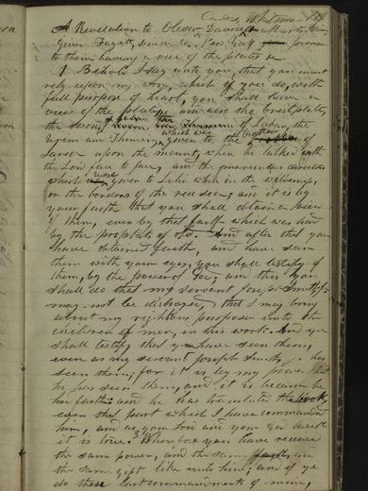D&C 17 on JosephSmithPapers.org
The revelation, now known as Doctrine and Covenants 17, made this promise to Cowdery, Whitmer, and Harris: “you must rely upon my word which if you do with full purpose of heart you shall have a view of the plate and also the breastplate the sword of Laban the Urim and Thumim ... and after that you have obtained faith and have seen them with your eyes you shall testify of them by the power of God.”8
Days later, the prophecy was dramatically fulfilled. “It was in the latter part of June, 1829,” Whitmer wrote. “Joseph, Oliver Cowdery and myself were together, and the angel showed them [the plates] to us. ... [We were] sitting on a log when we were overshadowed by a light more glorious than that of the sun. In the midst of this light, but a few feet from us, appeared a table upon which were many golden plates, also the sword of Laban and the directors. I saw them as plain as I see you now, and distinctly heard the voice of the Lord declaiming that the records of the plates of the Book of Mormon were translated by the gift and power of God.”9
Joseph Smith and Martin Harris had a similar experience, and as the manuscript was prepared for printing, Cowdery, Whitmer, and Harris signed a joint statement that has been included in each of the more than 120 million copies of the Book of Mormon printed since then. It reads in part:
“And we declare with words of soberness, than an angel of God came down from heaven, and he brought and laid before our eyes, that we beheld and saw the plates, and the engravings thereon; and we know that it is by the grace of God the Father, and our Lord Jesus Christ, that we beheld and bear record that these things are true.10

