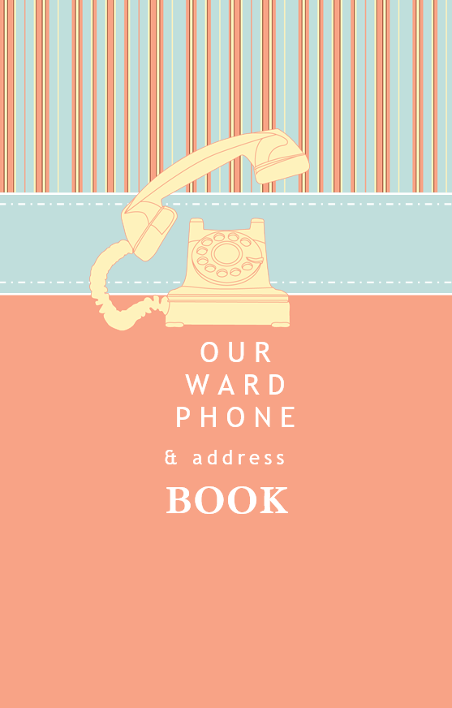
To insert a new page of contacts:
- Press Ctrl+End to move to the end of the document
- On the Insert Tab click Quick Parts, and click New Contact Page
To remove these instructions:
- Right-click this row and click Delete Rows

Type image caption here | Type image caption here | Type image caption here
Type image caption here | Type image caption here | Type image caption here
Type image caption here | Type image caption here | Type image caption here
Type image caption here | Type image caption here | Type image caption here
Type image caption here | Type image caption here | Type image caption here
Type image caption here | Type image caption here | Type image caption here
Type image caption here | Type image caption here | Type image caption here
Type image caption here | Type image caption here | Type image caption here

