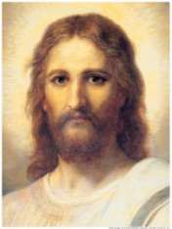
What would What would What would What would What would What would What would
Jesus do? Jesus do? Jesus do? Jesus do? Jesus do? Jesus do? Jesus do?

What would What would What would What would What would What would What would
Jesus do? Jesus do? Jesus do? Jesus do? Jesus do? Jesus do? Jesus do?

